**BIT302 SOFTWARE ENGINEERING**

**Assignment 3**

HELP COVID-19 Testing Information System (CTIS) Website – Design Specification Document



**Team Leader**

I Made Siva Aditya Surya / E1800176

[mdsivaaditya@gmail.com](mailto:mdsivaaditya@gmail.com)

**Member**

Ida Bagus Gede Awidya Andika / E1800182

[awidyaandika@gmail.com](mailto:awidyaandika@gmail.com)

2021

**Table of Contents**

**Table of Contents** i

**1.** **Assignment 1 and 2 Follow Up** 2

**1.1.** **Updates Analysis Design / Documentation** 2

**1.1.1** **Expanded Use Cases, System Sequence Diagrams, & Contracts** 2

**1.1.2** **Use Case Diagram** 35

**1.1.3** **Design Class Diagram** 36

**1.1.4** **Database Design** 37

**1.1.5** **Database Dictionary** 37

**1.2.** **Problem in Iteration 1** 41

**2.** **Iteration 2** 42

**2.1.** **Identification of Use Cases** 42

**2.2.** **Screenshots** 43

**2.3.** **Test Objectives** 69

**2.4.** **Test Plan** 70

**2.5.** **Test Cases** 71

**2.5.1.** **Unit Testing** 71

**2.5.2.** **Integration Testing** 85

**2.5.3.** **System Testing** 93

**2.6.** **Test Analysis Report** 103

**3.** **Closing and Review** 104

**3.1.** **Final Gantt Chart** 104

**3.2.** **Collaboration via GitHub** 105

**3.3.** **Conclusion/Review** 106

**Bibliography** 109

1. **Assignment 1 and 2 Follow Up**
   1. **Updates Analysis Design / Documentation**
2. **Expanded Use Cases, System Sequence Diagrams, & Contracts**
3. **Login**

**Prepared by: Ida Bagus Gede Awidya Andika**

* Expanded Use Case

|  |  |
| --- | --- |
| Use Case | Log in |
| Goal in Context | Allow User to login to the system |
| Primary Actor  Secondary Actor | Test Centre Officer and Patient  **-** |
| Typical Course of Events | |
| Actor Actions | **System Response** |
| 1. Process begins when the Test Centre Officer/Patient input their username or email and password then click the login button | 2. System will verify the input data, whether it matches the data in database or not |
|  | 3. System will navigate the user to their dashboard |
| Alternative Course | |
| 1a: If Test Centre Officer or Patient inputs incorrect username or email and password, then the system will display a warning notification that includes an instruction to try log in again | |

* System Sequence Diagram

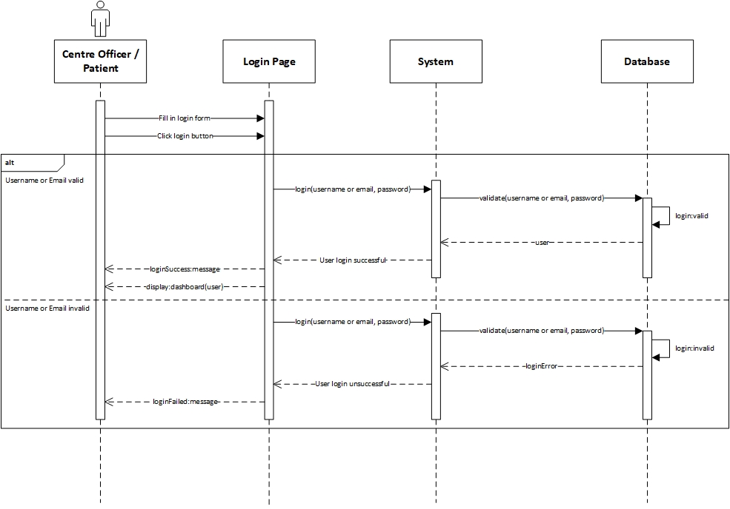

*Figure 1. Login System Sequence Diagram*

* Contract

|  |  |
| --- | --- |
| **Cross References** | **Login** |
| Operation | login(username or email, password) |
| Responsible | To access the user’s dashboard. |
| Pre-conditions | * User object must be available * A valid username or email and password |
| Post-conditions | * Session was created (instance creation) * Session was associated with the User (association formed) |
| **Cross References** | **Login** |
| Operation | login(username or email, password) |
| Responsible | To access the user’s dashboard. |
| Pre-conditions | * User object must be available * Invalid username or email and password |
| Post-conditions | * Session was not created |

1. **View Test Kit**

**Prepared by: Ida Bagus Gede Awidya Andika**

* Expanded Use Case

|  |  |
| --- | --- |
| Use Case | View Test Kit |
| Goal in Context | Allow Officer to view a list of test kit and stock |
| Primary Actor  Secondary Actor | Test Centre Officer  **-** |
| Typical Course of Events | |
| Actor Actions | **System Response** |
| 1. Process begins after Test Centre Officer has successfully login to system | 1. System will navigate Test Centre Officer to their dashboard |
| 1. Test Centre Officer clicks Test Kit menu | 1. System displays a list of Test Kit data |
| Alternative Course | |
| - | |

* System Sequence Diagram

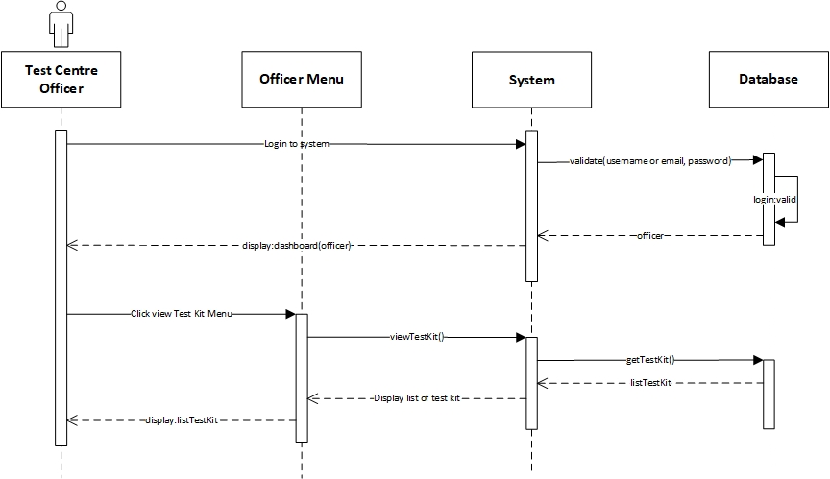

*Figure 2. View Test Kit System Sequence Diagram*

* Contract

|  |  |
| --- | --- |
| **Cross References** | **View Test Kit** |
| Operation | login(username or email, password) |
| Responsible | To access the officer’s dashboard. |
| Pre-conditions | * Officer object must be available * A valid username or email and password |
| Post-conditions | * Session was created (instance creation) * Session was associated with the Officer (association formed) |
| **Cross References** | **View Test Kit** |
| Operation | viewTestKit() |
| Responsible | To view a list of all Test Kit data. |
| Pre-conditions | testKit object must be available |
| Post-conditions | * ListTestKit was created (instance creation) * ListTestKit was associated with viewMenu (association formed) |

1. **Manage Test Kit Stock**

**Prepared by: Ida Bagus Gede Awidya Andika**

* Expanded Use Case

|  |  |
| --- | --- |
| Use Case | Manage Test Kit Stock |
| Goal in Context | Allow Test Centre Manager to add Test Kit or update Test Kit stock |
| Primary Actor  Secondary Actor | Test Centre Manager  **-** |
| Typical Course of Events | |
| Actor Actions | **System Response** |
| 1. Process begins after Test Centre Manager has successfully login to system | 1. System will navigate Test Centre Manager to their dashboard |
| 1. Test Centre Manager clicks Test Kit menu | 1. System will display a list of Test Kit data |
| 1. Test Centre Manager clicks Add Data | 1. System will navigate Test Centre Manager to Add Test Kit page and display Test Kit data form |
| 1. Test Centre Manager fills in the data for the name of the test kit and the amount of stock on the form provided, then clicks the save button | 1. System will store the data that has been entered by the Test Centre Manager into the database then Test Centre Manager will be directed to the Test Kit page and a message that notifies success in adding the Test Kit is displayed |
| Alternative Course | |
| 5a: If the test kit has been recorded in the database, the Test Center Manager will be able to update the amount of test kit stocks available when pressing the edit button on the Test Kit menu | |

* System Sequence Diagram

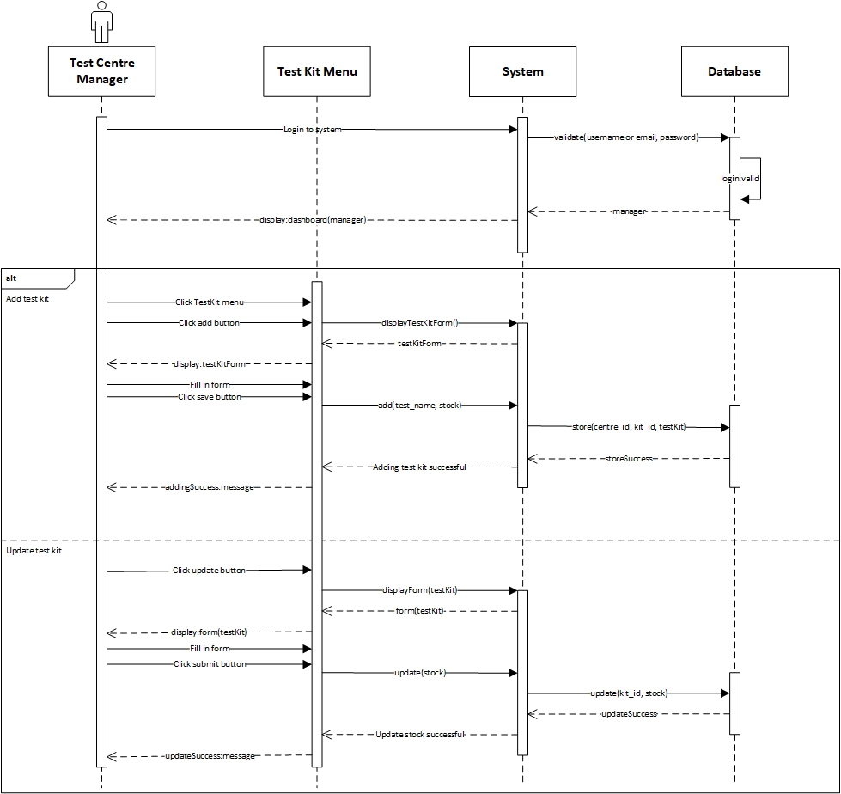

*Figure 3. Manage Test Kit Stock System Sequence Diagram*

* Contract

|  |  |
| --- | --- |
| **Cross References** | **Manage Test Kit Stock** |
| Operation | login(username or email, password) |
| Responsible | To access the manager’s dashboard. |
| Pre-conditions | * Manager object must be available * A valid username or email and password |
| Post-conditions | * Session was created (instance creation) * Session was associated with the Manager (association formed) |
| **Cross References** | **Manage Test Kit Stock** |
| Operation | add(test_name, stock) |
| Responsible | To add new test kit with name and available stock. |
| Pre-conditions | * Manager object must be available * TestCentre object must be available * Session must already be created * Test name and stock data is available |
| Post-conditions | * TestKit was created (instance creation) * kit_id was generated (attribute modification) * TestKit was associated with the Test Centre (association formed) |
| **Cross References** | **Manage Test Kit Stock** |
| Operation | update(stock) |
| Responsible | To update available stock from test kit. |
| Pre-conditions | * Manager object must be available * Session must already be created * TestKit object must be available * Stock data is available |
| Post-conditions | Stock was updated (attribute modification) |

1. **Register Test Centre**

**Prepared by: Ida Bagus Gede Awidya Andika**

* Expanded Use Case

|  |  |
| --- | --- |
| Use Case | Register Test Centre |
| Goal in Context | Allow Test Centre to be created and recorded for the Manager |
| Primary Actor  Secondary Actor | Test Centre Manager  **-** |
| Typical Course of Events | |
| Actor Actions | **System Response** |
| 1. Process begins when Test Centre Manager first login to the system | 1. System will navigate Test Centre Manager to register test centre page and display test centre data form |
| 1. Test Centre Manager fills in the name, address, postal code, phone and city of the test centre on the form provided and then clicks the save button | 1. System will store the data that has been inputted by the Test Centre Manager into the database, then Test Centre Manager will be directed to the test centre page and a message that notifies success in registering the test centre is displayed |
| Alternative Course | |
| - | |

* System Sequence Diagram

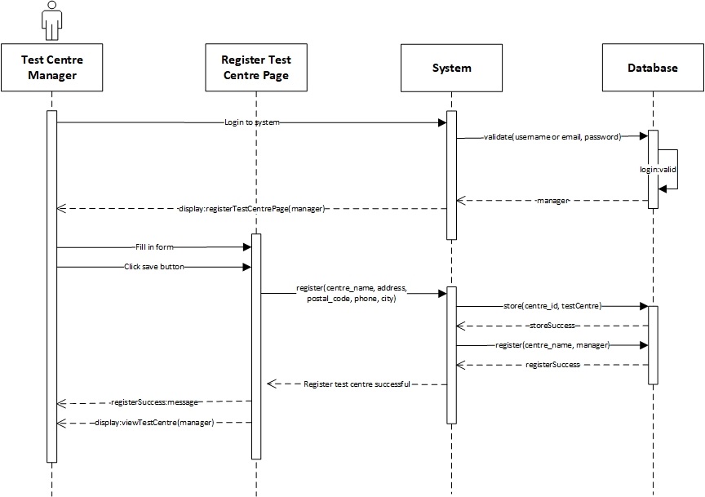

*Figure 4. Register Test Centre System Sequence Diagram*

* Contract

|  |  |
| --- | --- |
| **Cross References** | **Register Test Centre** |
| Operation | login(username or email, password) |
| Responsible | To access the manager’s dashboard. |
| Pre-conditions | * Manager object must be available * A valid username or email and password |
| Post-conditions | * Session was created (instance creation) * Session was associated with the Manager (association formed) |
| **Cross References** | **Register Test Centre** |
| Operation | register(centre_name, address, postal_code, phone, city) |
| Responsible | To register test centre and record for the manager. |
| Pre-conditions | * Manager object must be available * Session must already be created * Test centre is not registered for Manager * Test centre data is available |
| Post-conditions | * TestCentre was created (instance creation) * centre_id was generated (attribute modification) * Manager was associated with the TestCentre (association formed) |

1. **View Test Centre Officer**

**Prepared by: Ida Bagus Gede Awidya Andika**

* Expanded Use Case

|  |  |
| --- | --- |
| Use Case | View Test Centre Officer |
| Goal in Context | Allow Officer to view a list of all employed Officer in their Test Centre |
| Primary Actor  Secondary Actor | Test Centre Officer  **-** |
| Typical Course of Events | |
| Actor Actions | **System Response** |
| 1. Process begins after Test Centre Officer has successfully login to system | 1. System will navigate Test Centre Officer to their dashboard |
| 1. Test Centre Officer clicks Test Centre Officer menu | 1. System will display a list of Test Centre Officer data |
| Alternative Course | |
| - | |

* System Sequence Diagram

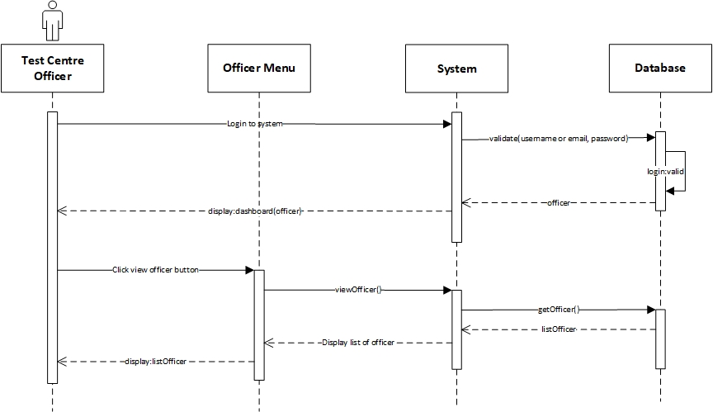

*Figure 5. View Test Centre Officer System Sequence Diagram*

* Contract

|  |  |
| --- | --- |
| **Cross References** | **View Test Centre Officer** |
| Operation | login(username or email, password) |
| Responsible | To access the officer’s dashboard. |
| Pre-conditions | * Officer object must be available * A valid username or email and password |
| Post-conditions | * Session was created (instance creation) * Session was associated with the Officer (association formed) |
| **Cross References** | **View Test Centre Officer** |
| Operation | viewOfficer() |
| Responsible | To view a list of test centre data. |
| Pre-conditions | * Officer object must be available * Session must already be created |
| Post-conditions | * ListOfficer was created (instance creation) * ListOfficer was associated with viewMenu (association formed) |

2. **Record Tester**

**Prepared by: Ida Bagus Gede Awidya Andika**

* Expanded Use Case

|  |  |
| --- | --- |
| Use Case | Record Tester |
| Goal in Context | Allow Manager to record Officer as Tester |
| Primary Actor  Secondary Actor | Test Centre Manager  Test Centre Officer |
| Typical Course of Events | |
| Actor Actions | **System Response** |
| 1. Process begins after Test Centre Manager successfully login to system | 1. System will navigate Test Centre Manager to their dashboard |
| 1. Test Centre Manager clicks Test Centre Officer menu | 1. System will display a list of Test Centre Officer data |
| 1. Test Centre Manager clicks edit button on the Test Centre Officer whose position is going to be changed to tester | 1. System will navigate Test Centre to the Test Centre Officer edit page and display the Test Centre Officer data form |
| 1. Test Centre Manager changes the position of Test Centre Officer from “officer” to “tester” | 1. System will store the data that has been entered by the Test Centre Manager into the database then the Test Centre Manager will be navigated to the Tester page and a message appears that notify success in recording tester is displayed |
| Alternative Course | |
| 5a: If there are no test centre officer that has been recorded in database or test centre manager wants to record new test centre officer with position “tester”, then the test centre manager will clicks add centre officer button and fill in all the required data in the form as well as setting the position to “tester”. Test centre manager will click the submit button to record the tester into database, then a message that notify success in recording tester is displayed | |

* System Sequence Diagram

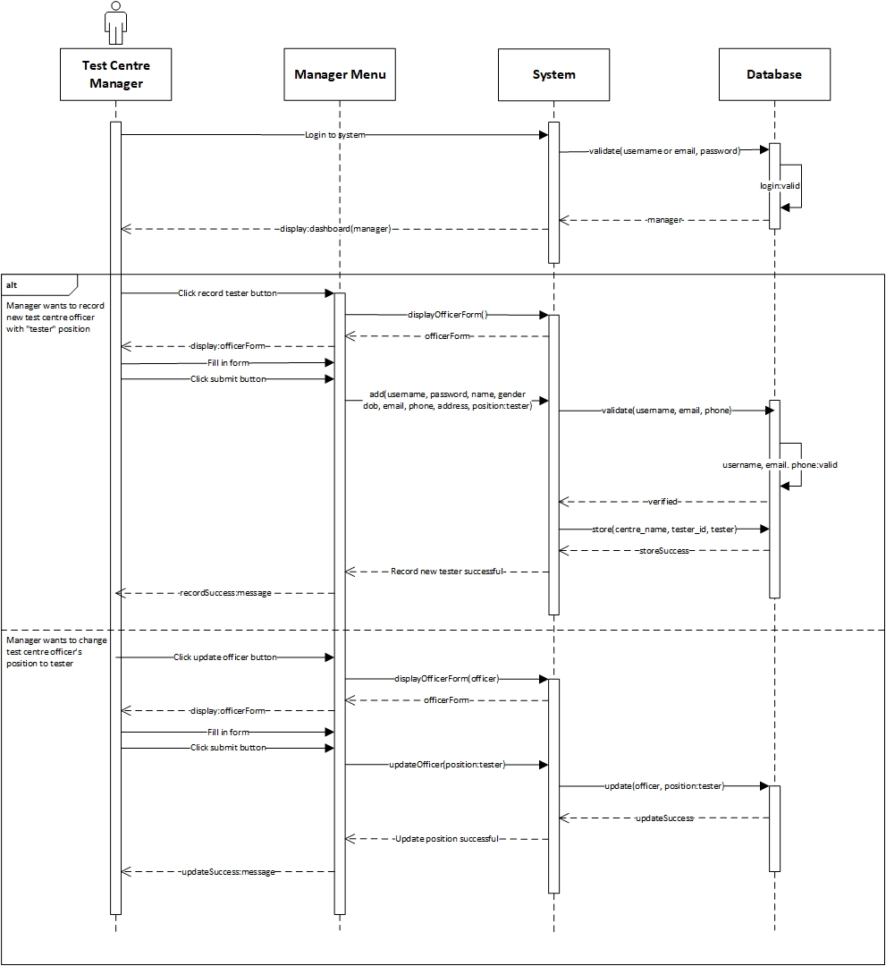

*Figure 6. Record Tester System Sequence Diagram*

* Contract

|  |  |
| --- | --- |
| **Cross References** | **Record Tester** |
| Operation | login(username or email, password) |
| Responsible | To access the manager’s dashboard. |
| Pre-conditions | * Manager object must be available * A valid username or email and password |
| Post-conditions | * Session was created (instance creation) * Session was associated with the Manager (association formed) |
| **Cross References** | **Record Tester** |
| Operation | updateOfficer(position:tester) |
| Responsible | To update the position of test centre officer to tester. |
| Pre-conditions | * Manager object must be available * Session must already be created * Officer object must be available |
| Post-conditions | Position was updated (attribute modification) |
| **Cross References** | **Record Tester** |
| Operation | add(username, password, name, gender, dob, email, phone, address, position:tester) |
| Responsible | To record Tester |
| Pre-Conditions | * Manager object must be available * Session must already be created * TestCentre object must be available * Tester data must be available * A valid tester username, email, phone |
| Post-Conditions | * Tester was created (instance creation) * officer_id was generated (attribute modification) * Tester was associated with the TestCentre (association formed) |

1. **Record Officer**

**Prepared by: Ida Bagus Gede Awidya Andika**

* Expanded Use Case

|  |  |
| --- | --- |
| Use Case | Record Officer |
| Goal in Context | Allow Manager to record new Officer |
| Primary Actor  Secondary Actor | Test Centre Manager  Test Centre Officer |
| Typical Course of Events | |
| Actor Actions | **System Response** |
| 1. Process begins after Test Centre Manager successfully login to system | 1. System will navigate Test Centre Manager to their dashboard |
| 1. Test Centre Manager clicks Test Centre Officer menu | 1. System will display a list of Test Centre Officer data |
| 1. Test Centre Manager clicks Add Test Centre Officer button | 1. System will navigate Test Centre Manager to Add Test Centre Officer page and display Test Centre Officer data form |
| 1. Test Centre Manager fills in the data for username, password, and other Test Centre Officer data on the form provided and then clicks the save button | 1. Sistem will store the data that has been entered by Test Centre Manager into the database then Test Centre Manager will be navigated to the Test Centre Officer page and a message that notifies success in recording Test Centre Officer is displayed |
| Alternative Course | |
| * 7a: If username, email or phone is already exists. Then the system will display a warning notification that includes an instruction to try full fill form again | |

* System Sequence Diagram

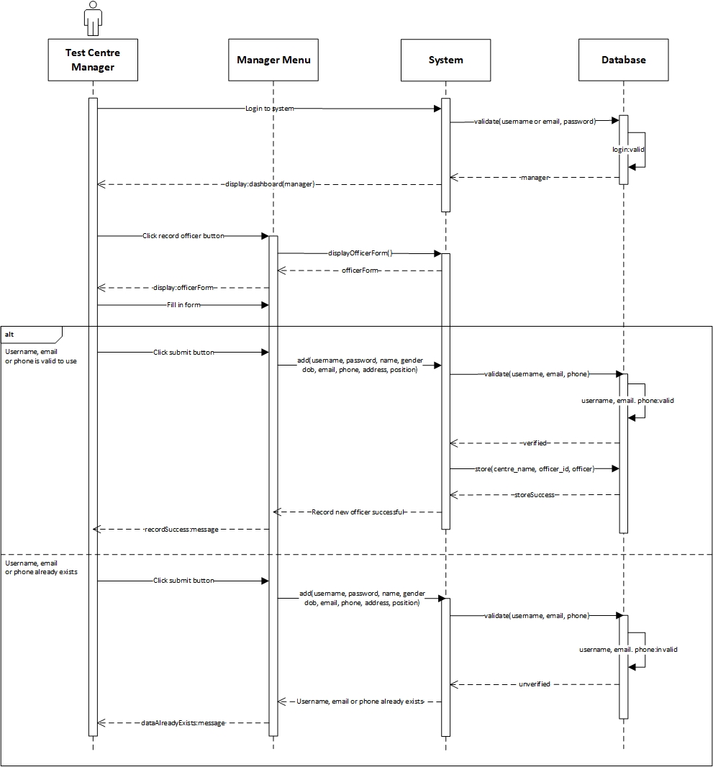

*Figure 7. Record Officer System Sequence Diagram*

* Contract

|  |  |
| --- | --- |
| **Cross References** | **Record Officer** |
| Operation | login(username or email, password) |
| Responsible | To access the manager’s dashboard. |
| Pre-conditions | * Manager object must be available * A valid username or email and password |
| Post-conditions | * Session was created (instance creation) * Session was associated with the Manager (association formed) |
| **Cross References** | **Record Officer** |
| Operation | add(username, password, name, gender, dob, email, phone, address, position) |
| Responsible | To record Officer |
| Pre-conditions | * Manager object must be available * Session must already be created * TestCentre object must be available * Officer data must be available * A valid officer username, email, phone |
| Post-conditions | * Officer was created (instance creation) * officer_id was generated (attribute modification) * Officer was associated with the TestCentre (associate modification) |
| **Cross References** | **Record Officer** |
| Operation | add(username, password, name, gender, dob, email, phone, address, position) |
| Responsible | To record Officer |
| Pre-conditions | * Manager object must be available * Session must already be created * TestCentre object must be available * Officer data must be available |
| Post-conditions | * Officer was not created |

1. **Record New Test**

**Prepared by: I Made Siva Aditya Surya**

* Expanded Use Case

|  |  |
| --- | --- |
| Use Case | Record New Test |
| Goal in Context | Allow Tester to record New Covid Test data |
| Primary Actor  Secondary Actor | Tester  Patient |
| Typical Course of Events | |
| Actor Actions | **System Response** |
| 1. Process begins after Tester successfully login to system | 1. System will navigate Tester to their dashboard |
| 1. Tester clicks Covid Test menu | 1. System will display a list of Covid Test data |
| 1. Tester clicks add New Test button | 1. System will navigate Tester to Add New test page and display Covid Test data form |
| 1. Tester fills in the patient name, test date, type test, symptoms and result date in the form provided and then clicks the save button | 1. System will store the data that has been entered by Tester into the database then the Tester will be directed to the Covid Test page and a message that notifies success in recording new test is displayed |
| Alternative Course | |
| - | |

* System Sequence Diagram

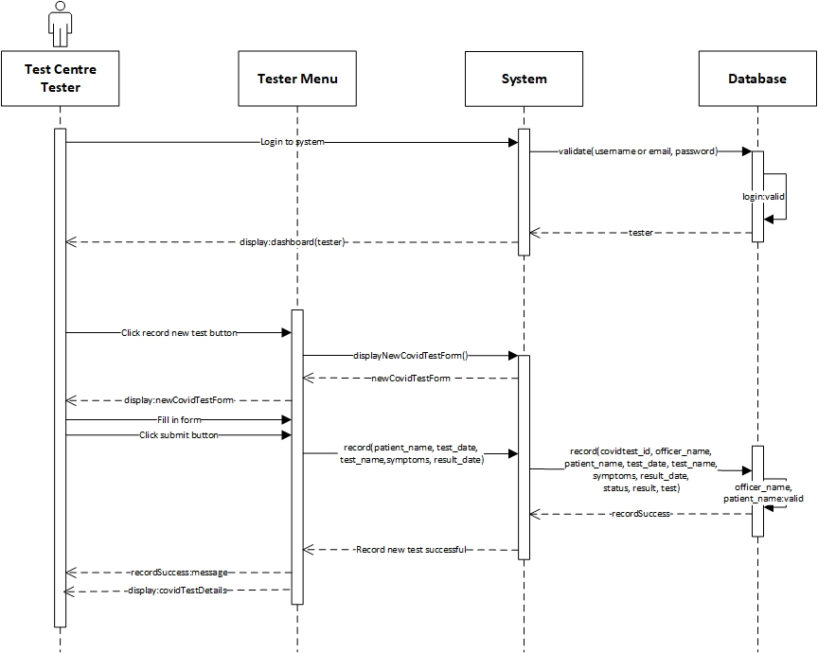

*Figure 8. Record New Test System Sequence Diagram*

* Contract

|  |  |
| --- | --- |
| **Cross References** | **Record New Test** |
| Operation | login(username or email, password) |
| Responsible | To access the tester’s dashboard. |
| Pre-conditions | * Tester object must be available * A valid username or email and password |
| Post-conditions | * Session was created (instance creation) * Session was associated with the Tester (association formed) |
| **Cross References** | **Record New Test** |
| Operation | record(patient_name, test_date, test_name, symptoms, result_date) |
| Responsible | To record Covid Test data from Patient. |
| Pre-conditions | * Tester object must be available * Session must already be created * TestKit object must be available * Patient data is available * A valid patient officer_name, patient_name |
| Post-conditions | * Patient was created (instance creation) * patient_name was generated (attribute modification) * Tester was created (instance creation) * officer_name was generated (attribute modification) * CovidTest was created (instance creation) * covidtest_id was generated (attribute modification) * test_date was generated (attribute modification) * status was generated (attribute modification) * result was generated (attribute modification) * CovidTest was associated with the Tester (association formed) * CovidTest was associated with the TestKit (association formed) * CovidTest was associated with the Patient (association formed) |

1. **Update Test Result**

**Prepared by: I Made Siva Aditya Surya**

* Expanded Use Case

|  |  |
| --- | --- |
| Use Case | Update Test Result |
| Goal in Context | Allow Tester to update Patient’s test result and status |
| Primary Actor  Secondary Actor | Tester  Patient |
| Typical Course of Events | |
| Actor Actions | **System Response** |
| 1. Process begins after Tester successfully login to system | 1. System will navigate Tester to their dashboard |
| 1. Tester clicks Covid Test menu | 1. System will display a list of Covid Test data |
| 1. Tester clicks the edit button on the Covid Test data that needs to be updated | 1. System will navigate Tester to edit Covid Test page and display Covid Test data form |
| 1. Tester updates result date, status and result | 1. System will store the data that has been entered by Tester into the database then Tester will be navigated to the Covid Test page and a message that notifies success in updating Covid Test data is displayed |
| Alternative Course | |
| - | |

* System Sequence Diagram

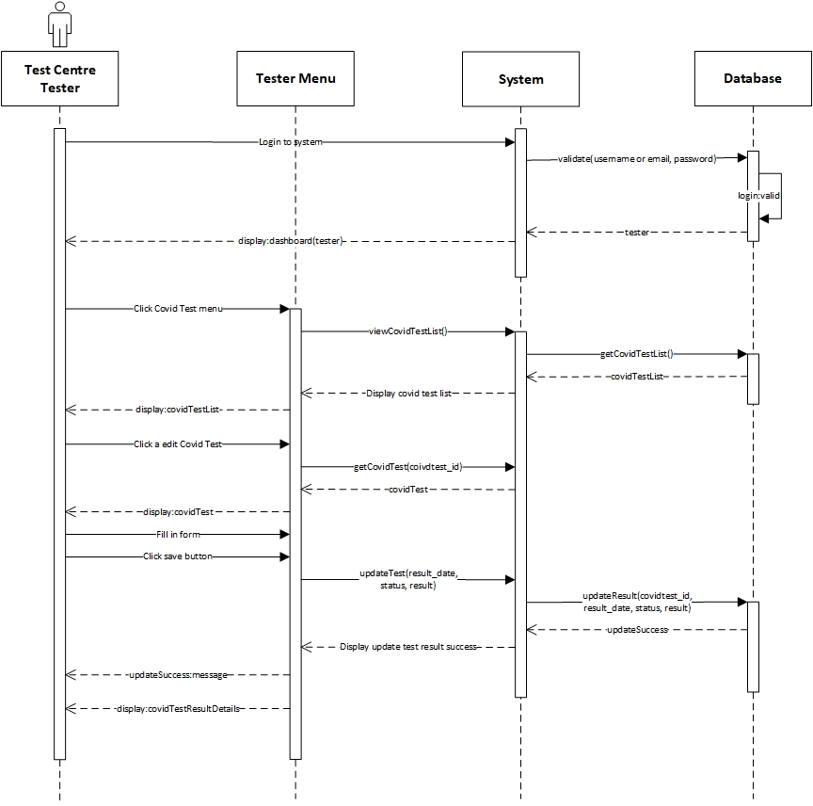

*Figure 9. Update Test Result System Sequence Diagram*

* Contract

|  |  |
| --- | --- |
| **Cross References** | **Update Test Result** |
| Operation | login(username or email, password) |
| Responsible | To access the tester’s dashboard. |
| Pre-conditions | * Tester object must be available * A valid username or email and password |
| Post-conditions | * Session was created (instance creation) * Session was associated with the Tester (association formed) |
| **Cross References** | **Update Test Result** |
| Operation | updateTest(result_date, status, result) |
| Responsible | To update the test result and status. |
| Pre-conditions | * Tester object must be available * Session must already be created * CovidTest object must be available * Patient data must be available * Test result data must be available |
| Post-conditions | * result_date was updated (attribute modification) * status was updated (attribute modification) * result was updated (attribute modification) |

* 1. **Generate Test Report**

**Prepared by: I Made Siva Aditya Surya**

* Expanded Use Case

|  |  |
| --- | --- |
| Use Case | Generate Test Report |
| Goal in Context | Allow Officer to generate a list of test report that are administered in their Test Centre |
| Primary Actor  Secondary Actor | Test Centre Officer  **-** |
| Typical Course of Events | |
| Actor Actions | **System Response** |
| 1. Process begins after Test Centre Officer successfully login to system | 1. System will navigate Test Centre Officer to their homepage |
| 1. Test Centre Officer click Covid Test menu | 1. System will display a list of all Covid Test report on the test centre which the officer is employed at |
| Alternative Course | |
| - | |

* System Sequence Diagram

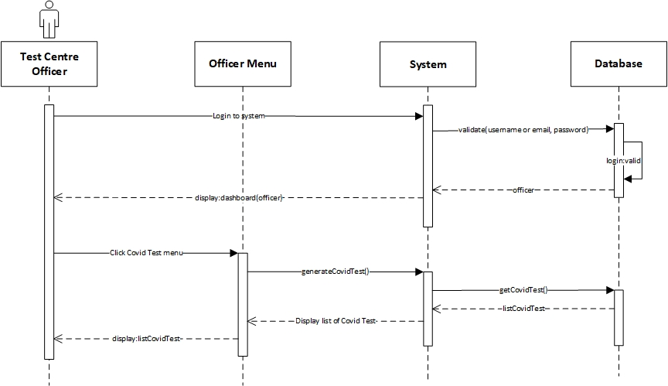

*Figure 10. Generate Test Report System Sequence Diagram*

* Contract

|  |  |
| --- | --- |
| **Cross References** | **Generate Test Report** |
| Operation | login(username or email, password) |
| Responsible | To access the officer’s dashboard. |
| Pre-conditions | * Officer object must be available * A valid username or email and password |
| Post-conditions | * Session was created (instance creation) * Session was associated with the Officer (association formed) |
| **Cross References** | **Generate Test Report** |
| Operation | generateCovidTest() |
| Responsible | To view a list of all Covid Test data. |
| Pre-conditions | * Officer object must be available * Session must already be created * CovidTest object must be available |
| Post-conditions | * ListCovidTest was created (instance creation) * ListCovidTest was associated with viewMenu (association formed) |

* 1. **View Testing History**

**Prepared by: I Made Siva Aditya Surya**

* Expanded Use Case

|  |  |
| --- | --- |
| Use Case | View Testing History |
| Goal in Context | Allow Patient to view their testing history |
| Primary Actor  Secondary Actor | Patient  **-** |
| Typical Course of Events | |
| Actor Actions | **System Response** |
| 1. Process begins after Patient has successfully login to system | 1. System will navigate Patient to their dashboard |
| 1. Patient click COVID Test menu | 1. System will display a list of COVID Test data |
| Alternative Course | |
| - | |

* System Sequence Diagram

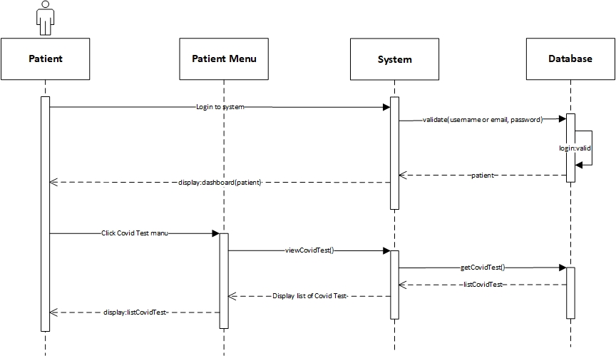

*Figure 11. View Testing History System Sequence Diagram*

* Contract

|  |  |
| --- | --- |
| **Cross References** | **View Testing History** |
| Operation | login(username or email, password) |
| Responsible | To access the patient’s dashboard. |
| Pre-conditions | * Patient object must be available * A valid username or email and password |
| Post-conditions | * Session was created (instance creation) * Session was associated with the Patient (association formed) |
| **Cross References** | **View Testing History** |
| Operation | viewCovidTest() |
| Responsible | To view a list of Covid Test. |
| Pre-conditions | * Patient object must be available * Session must already be created * CovidTest object must be available |
| Post-conditions | * ListCovidTest was created (instance creation) * ListCovidTest was associated with viewMenu (association formed) |

* 1. **Log Out**

**Prepared by: Ida Bagus Gede Awidya Andika**

* Expanded Use Case

|  |  |
| --- | --- |
| Use Case | Log Out |
| Goal in Context | Allow User to log out from the system |
| Primary Actor  Secondary Actor | Test Centre Officer and Patient  **-** |
| Typical Course of Events | |
| Actor Actions | **System Response** |
| 1. Process begins after Test Centre Officer/Patient has done everything they want to do on the system and wants to log out |  |
| 1. Test Centre Officer/Patient clicks logout button | 1. System will display a message questioning whether Test Centre Officer/Patient really wants to log out from system |
| 1. Test Centre Officer/Patient clicks Yes on the message | 1. System will end the login session of the Test Centre Officer/Patient and redirect to login page |
| Alternative Course | |
| 4a: If the officer/patient clicks on the No button, the log out process will be canceled | |

* System Sequence Diagram

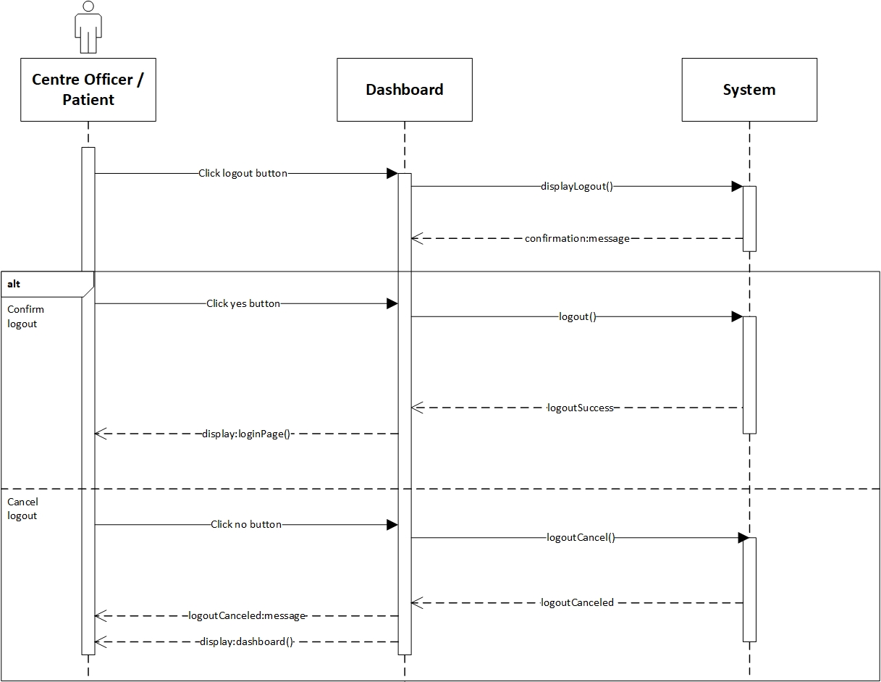

*Figure 12. Log Out System Sequence Diagram*

* Contract

|  |  |
| --- | --- |
| **Cross References** | **Logout** |
| Operation | logout() |
| Responsible | To log out or exit from the system |
| Pre-conditions | * User object must be available * Session must already be created * Confirm to logout |
| Post-conditions | Session was destroyed (instance deletion) |
| **Cross References** | **Logout** |
| Operation | logoutCancel() |
| Responsible | To cancel log out or exit from the system |
| Pre-conditions | * User object must be available * Session must already be created * Confirm to cancel logout |
| Post-conditions | Session was not destroyed |

1. **Record Patient**

**Prepared by: Ida Bagus Gede Awidya Andika**

* Expanded Use Case

|  |  |
| --- | --- |
| Use Case | Record Patient |
| Goal in Context | Allow Tester to record new patient |
| Primary Actor  Secondary Actor | Tester  Patient |
| Typical Course of Events | |
| Actor Actions | **System Response** |
| 1. Process begins after Tester successfully login to system | 1. System will navigate Tester to their dashboard |
| 1. Tester clicks Patient menu | 1. System will display a list of Patient data |
| 1. Tester clicks Add Patient button | 1. System will navigate Tester to Add Patient page and display Patient data form |
| 1. Tester fills in the data for username, password, and other Patient data on the form provided and then clicks the save button | 1. System will store the data that has been entered by Tester into the database then Tester will be navigated to the Patient page and a message that notifies success in recording Patient is displayed |
| Alternative Course | |
| * 7a: If username, email or phone is already exists. Then the system will display a warning notification that includes an instruction to try full fill form again | |

* System Sequence Diagram

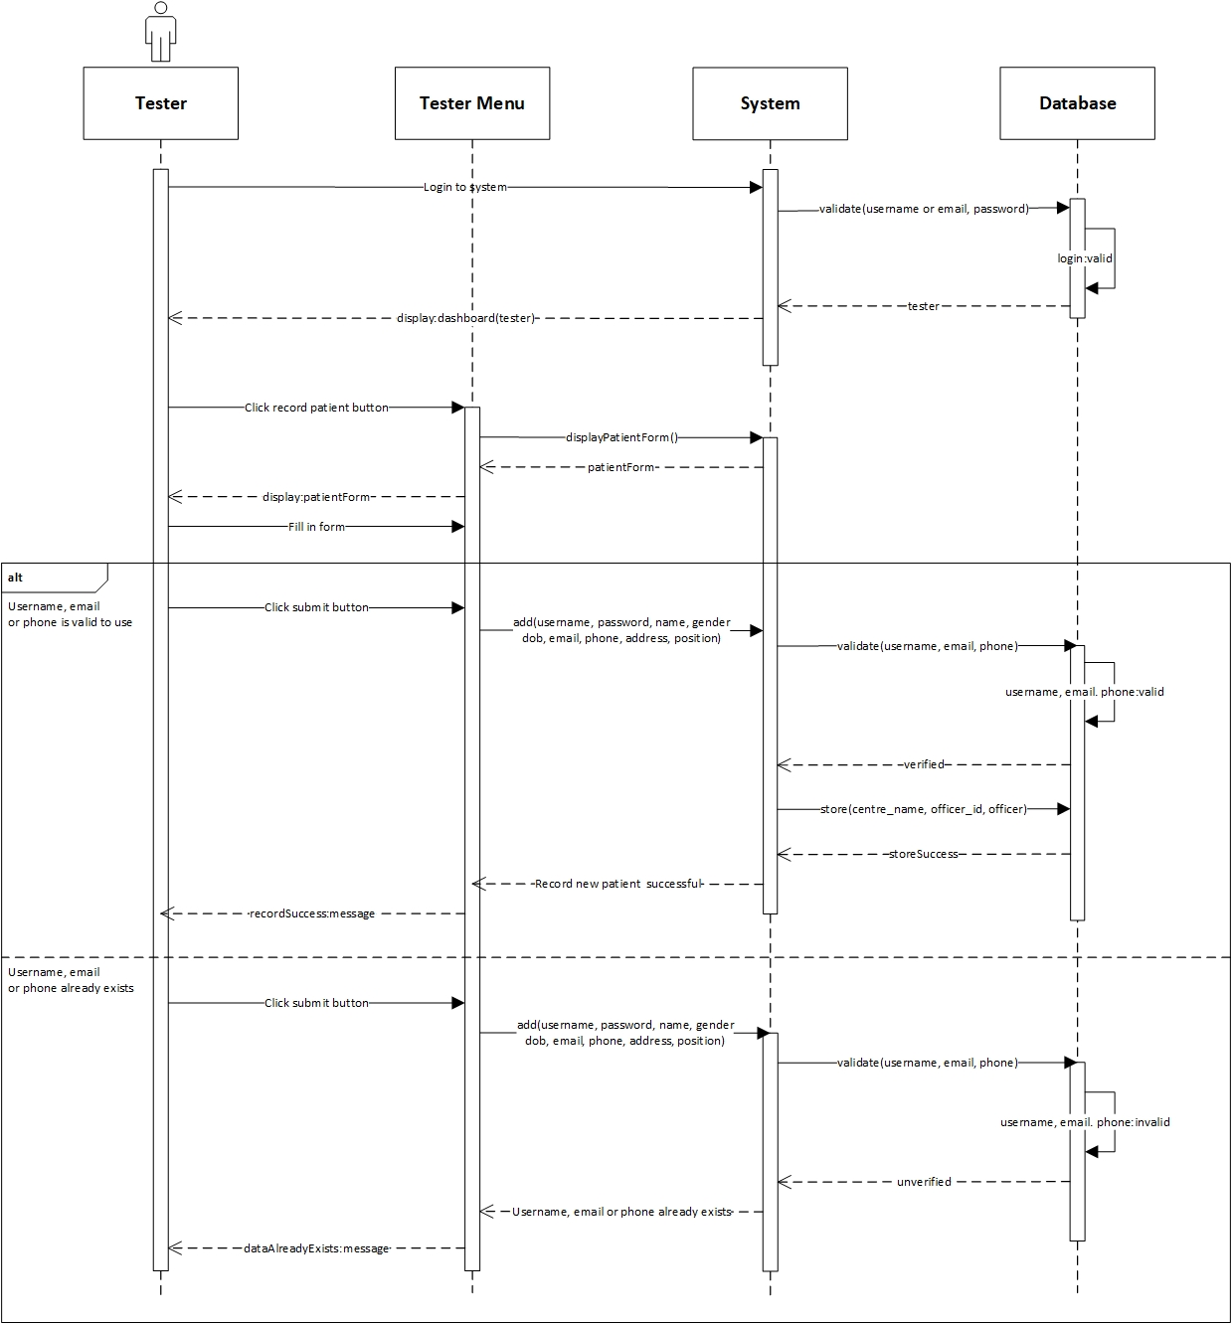

*Figure 13. Record Patient System Sequence Diagram*

* Contract

|  |  |
| --- | --- |
| **Cross References** | **Record Patient** |
| Operation | login(username or email, password) |
| Responsible | To access the tester’s dashboard. |
| Pre-conditions | * Tester object must be available * A valid username or email and password |
| Post-conditions | * Session was created (instance creation) * Session was associated with the Tester (association formed) |
| **Cross References** | **Record Patient** |
| Operation | add(username, password, name, gender, dob, email, phone, address, position) |
| Responsible | To record Patient |
| Pre-conditions | * Tester object must be available * Session must already be created * TestCentre object must be available * Patient data must be available * A valid patient username, email, phone |
| Post-conditions | * Patient was created (instance creation) * patient_id was generated (attribute modification) * Patient was associated with the TestCentre (associate modification) |
| **Cross References** | **Record Patient** |
| Operation | add(username, password, name, gender, dob, email, phone, address, position) |
| Responsible | To record Patient |
| Pre-conditions | * Tester object must be available * Session must already be created * TestCentre object must be available * Patient data must be available |
| Post-conditions | * Patient was not created |

1. **Use Case Diagram**

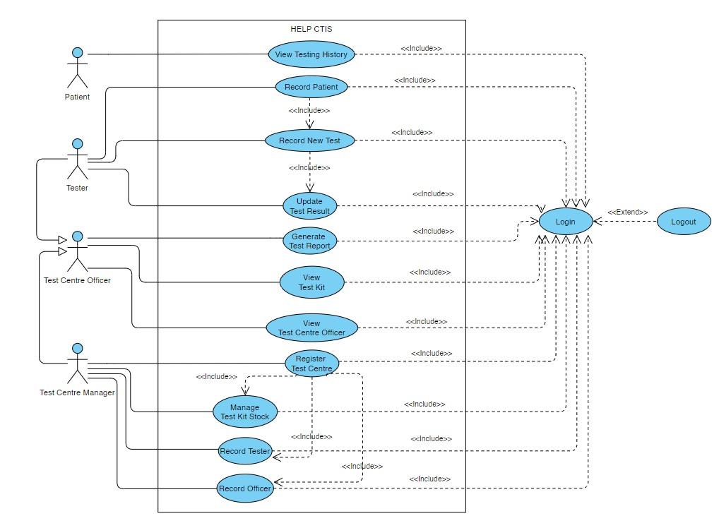

*Figure 14. Use Case Diagram*

In the second iteration of our project, we added one new use case which is “Record Patient” making the total of use cases in this project to be 13 use cases. Record Patient function was blended together in the use case “Record New Test” and was run simultaneously in the first iteration, then we decided to divide the use case into two parts, where the patient record must be done first before carrying out the new test record which we have clarified by adding the include relation to the 2 use cases. We hope that the addition of this use case can clarify the flow of the system that we developed.

Furthermore, we have added several new “include” relation between our use cases to represent the correct behaviour of the use cases in the developed system.

1. **Design Class Diagram**

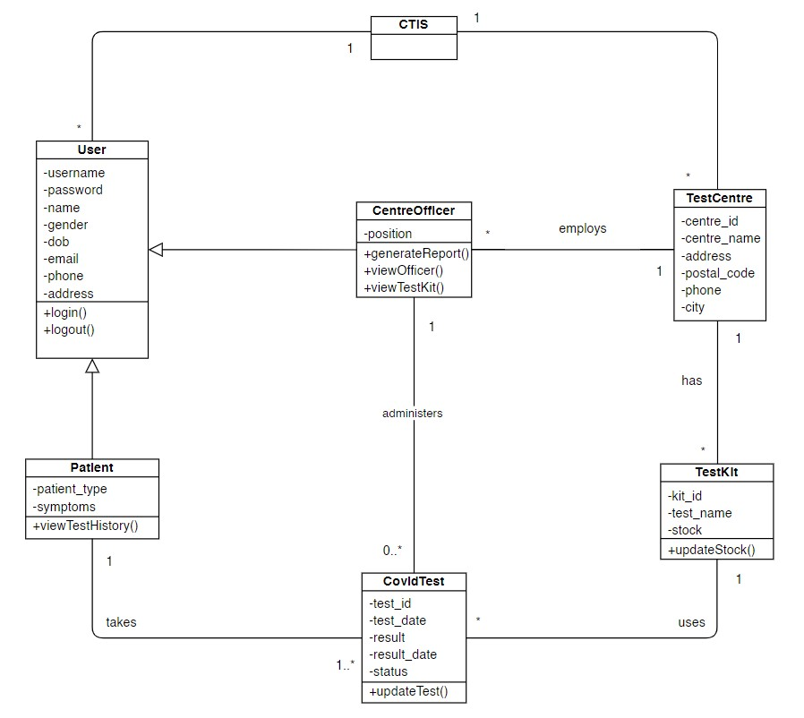

*Figure 15. Design Class Diagram*

There are no changes in this project’s design class diagram from the first iteration.

1. **Database Design**

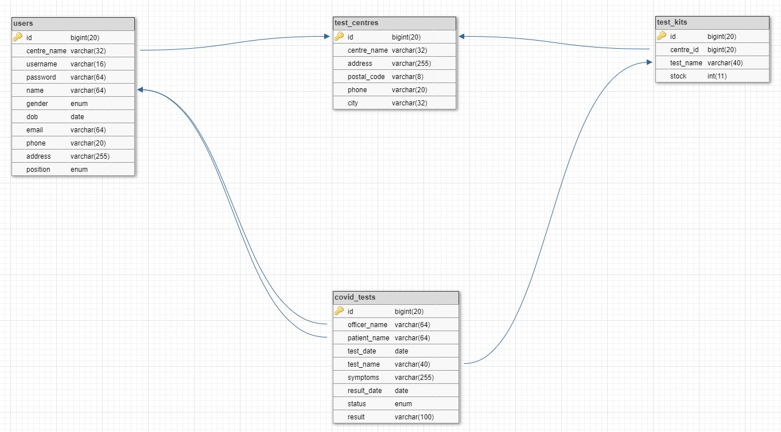

*Figure 16. Database Design*

We have updated our database design with consideration of the effectiveness of using our website framework. We merged the officer and patient tables in our previous design database into the user table in the second iteration of this project. We also updated the characteristics of the data in our tables which can be reviewed further in the next part which is the database dictionary of our database.

1. **Database Dictionary**

**“users" Table**

|  |  |  |  |  |
| --- | --- | --- | --- | --- |
| Field Name | Data Type | Field Size | Description | Example |
| id | bigint | 20 | A test centre officer’s unique ID number | 1 |
| centre_name | varchar | 32 | Name of the test centre that a test centre officer is employed at | Bali Med |
| username | varchar | 16 | Test centre officer unique account username for login | manager |
| password | password | 64 | Test centre officer account password for login | mangacan |
| name | varchar | 64 | Name of test centre officer | Manager |
| gender | enum |  | Gender of test centre officer | Male |
| dob | date |  | Birth date of test centre officer | 1998-01-03 |
| email | varchar | 64 | Email of test centre officer | [manager@gmail.com](mailto:manager@gmail.com) |
| phone | varchar | 20 | Phone number of test centre officer | 085734903945 |
| address | varchar | 255 | Home address of test centre officer | Jl. Perum Permai, No: 22 |
| position | enum |  | Employee position of test centre officer | manager |

**“test_centres” Table**

|  |  |  |  |  |
| --- | --- | --- | --- | --- |
| Field Name | Data Type | Field Size | Description | Example |
| id | bigint | 20 | A test centre’s unique ID number | 1 |
| centre_name | varchar | 32 | Name of test centre | Bali Med |
| address | varchar | 255 | Address of test centre | Jl. Mahendra 12x |
| postal_code | varchar | 8 | Postal code of the address | 80119 |
| phone | varchar | 20 | Hotline call centre number of test centre | (0361) 423215 |
| city | varchar | 32 | City/region where the test centre is located | Denpasar |

**“test_kits” Table**

|  |  |  |  |  |
| --- | --- | --- | --- | --- |
| Field Name | Data Type | Field Size | Description | Example |
| id | bigint | 20 | A test kit’s unique ID number | 1 |
| centre_id | bigint | 20 | ID number of the test centre that owns the test kit | 1 |
| test_name | varchar | 40 | Name of test kit | COVID-19 Antigen Rapid Testing (RTK-Ag) |
| stock | int | 11 | Available stock of test kit | 100 |

**“covid_tests” Table**

|  |  |  |  |  |
| --- | --- | --- | --- | --- |
| Field Name | Data Type | Field Size | Description | Example |
| id | bigint | 20 | A test centre’s unique ID number | 1 |
| officer_name | varchar | 64 | Name of the test centre officer who administered the test | David Nurbi |
| patient_name | varchar | 64 | Name of the patient who took the test | Sarah Wija |
| test_date | date |  | The date on which the test is performed | 2021-04-03 |
| test_name | varchar | 40 | Name of test kit which is used to perform the test | 1 |
| symptoms | varchar | 255 | COVID-19 symptoms of patient | Fever, sore throat, loss of taste and smell, dry cough, and difficulty of breathing. |
| result_date | date |  | Thet date on which the test results are issued | 2021-04-06 |
| status | enum |  | Status of the test | Completed |
| result | varchar | 100 | Result of the test | HEALTHY and NEGATIVE rapid test results with the COVID-19 Rapid Test |

1. **ERD**

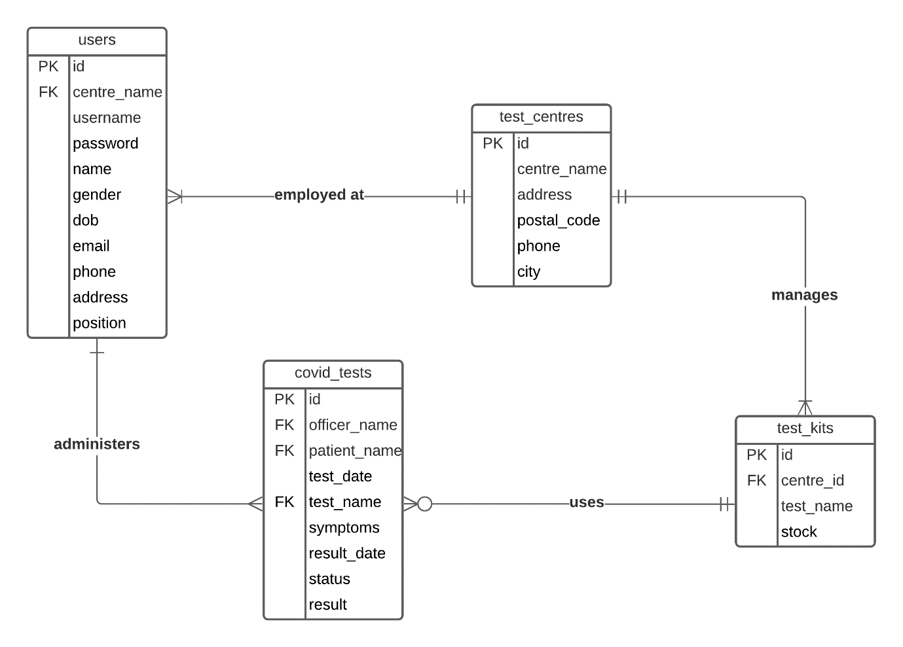

*Figure 17. ERD*

We have updated our ERD design with the same consideration of the database design updates of our project.

* 1. **Problem in Iteration 1**

In iteration 1, we did not find any significant problems. However, there is additional validation in the use case Register Test Center, where when the Manager has not added Test Center, the system will automatically deploy the Manager to the Register Test Center menu.

1. **Iteration 2**
   1. **Identification of Use Cases**

On the first iteration, we have run 3 use cases out of 12 existing use cases such as login, register test center, all this usecase which were developed by Ida Bagus Gede Awidya Andika. On the second iteration, there is the addition of a new use case, namely the Record Patient. All remaining usecases are already completed.

|  |  |  |  |
| --- | --- | --- | --- |
| No | Use Case | Developed by | Development & Testing |
| 1 | Login | Ida Bagus Gede Awidya Andika | Iteration 1 |
| 2 | Logout | Ida Bagus Gede Awidya Andika | Iteration 1 |
| 3 | Register Test Centre | Ida Bagus Gede Awidya Andika | Iteration 1 |
| 4 | Manage Test Kit Stock | Ida Bagus Gede Awidya Andika | Iteration 2 |
| 5 | Record Officer | Ida Bagus Gede Awidya Andika | Iteration 2 |
| 6 | Record Tester | Ida Bagus Gede Awidya Andika | Iteration 2 |
| 7 | View Test Kit | Ida Bagus Gede Awidya Andika | Iteration 2 |
| 8 | View Test Centre Officer | Ida Bagus Gede Awidya Andika | Iteration 2 |
| 9 | Generate Test Report | I Made Siva Aditya Surya | Iteration 2 |
| 10 | Record Patient | I Made Siva Aditya Surya | Iteration 2 |
| 11 | Record New Test | I Made Siva Aditya Surya | Iteration 2 |
| 12 | Update Test Result | I Made Siva Aditya Surya | Iteration 2 |
| 13 | View Testing History | I Made Siva Aditya Surya | Iteration 2 |

* 1. **Screenshots**
     + 1. **Login**

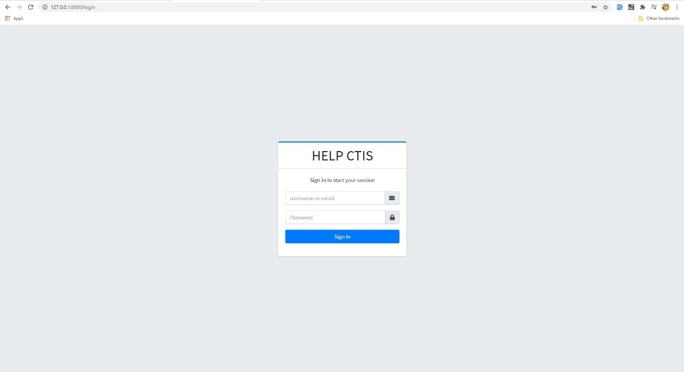

*Figure 18. Login*

**Validation for Login**

* If the user leaves empty field

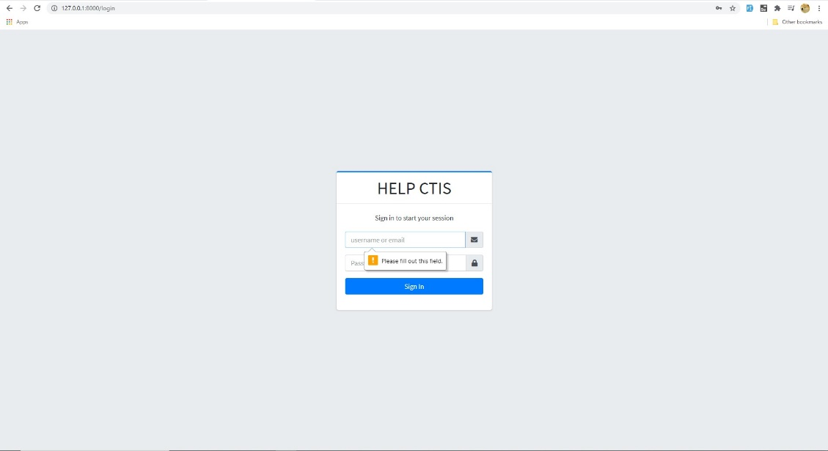

*Figure 19. Validation Login (empty field)*

* If the user enters wrong input

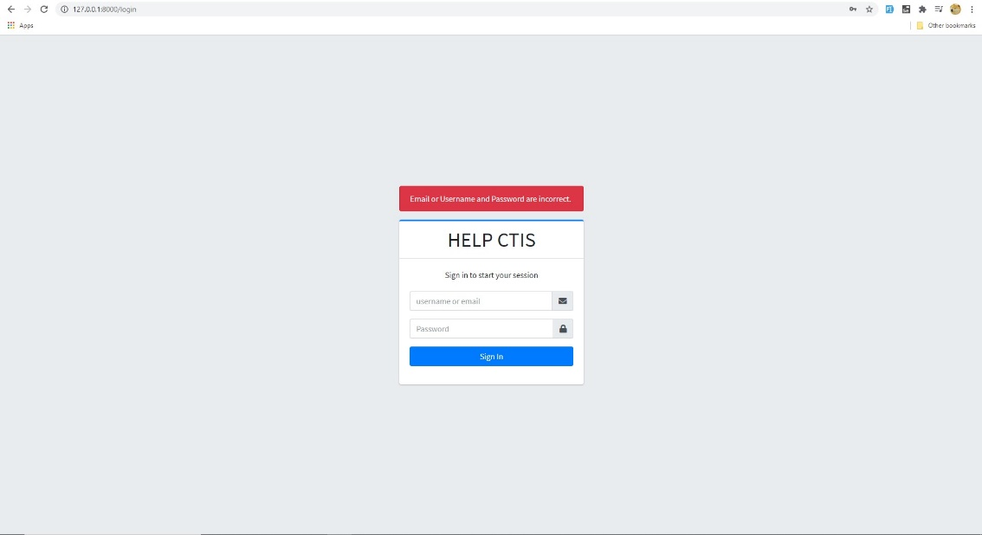

*Figure 20. Validation Login (empty field)*

1. **Register Test Centre**

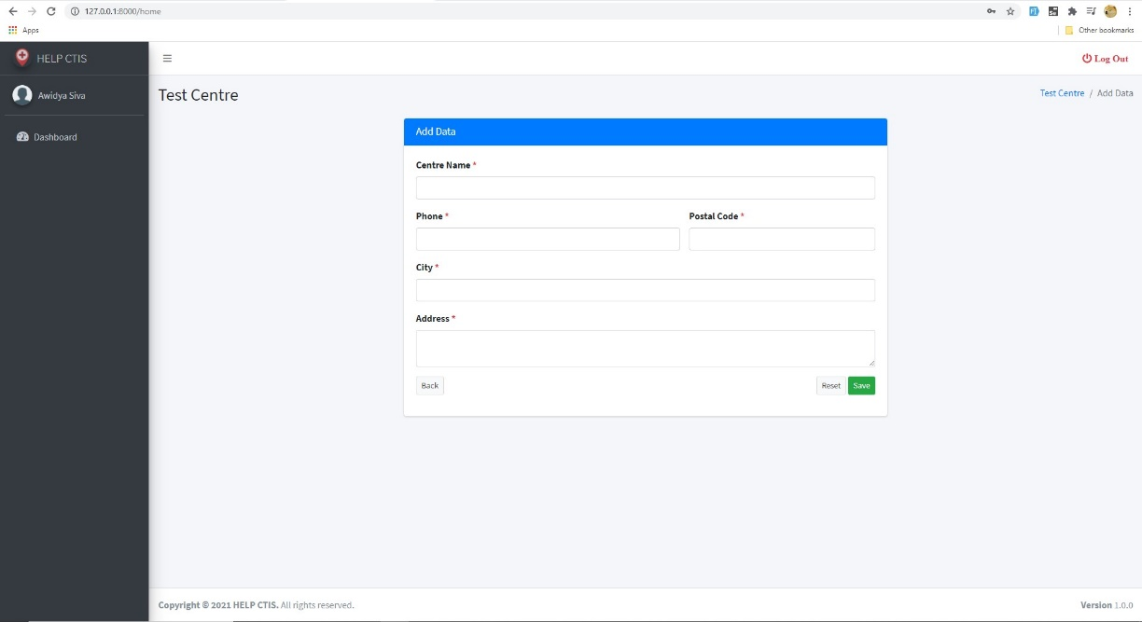

*Figure 21. Register Test Centre (add data)*

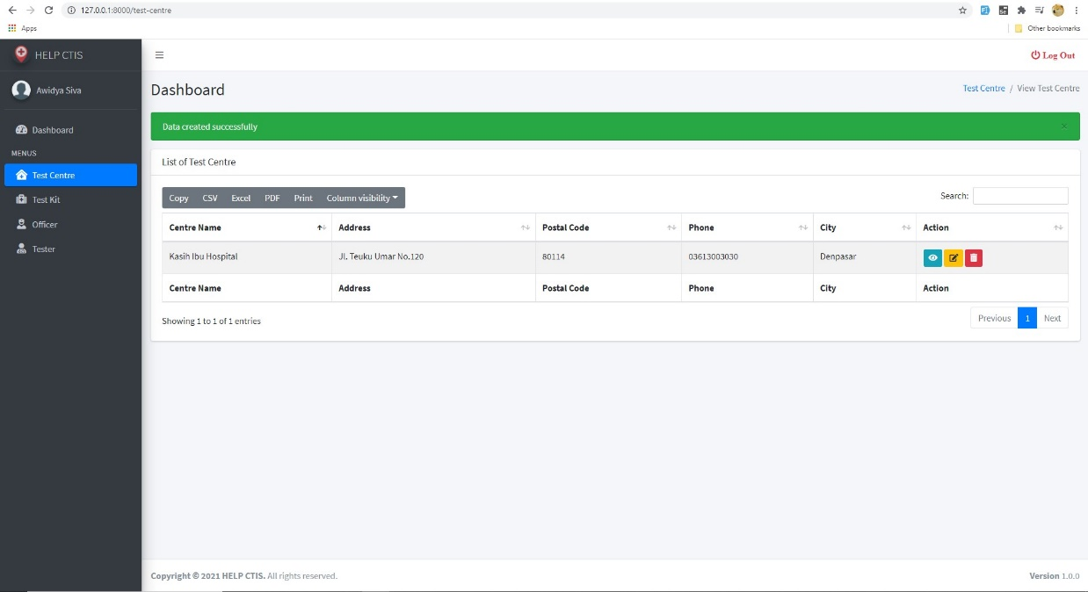

*Figure 22. Register Test Centre (success)*

**Validation for Register Test Centre**

* Data already exists

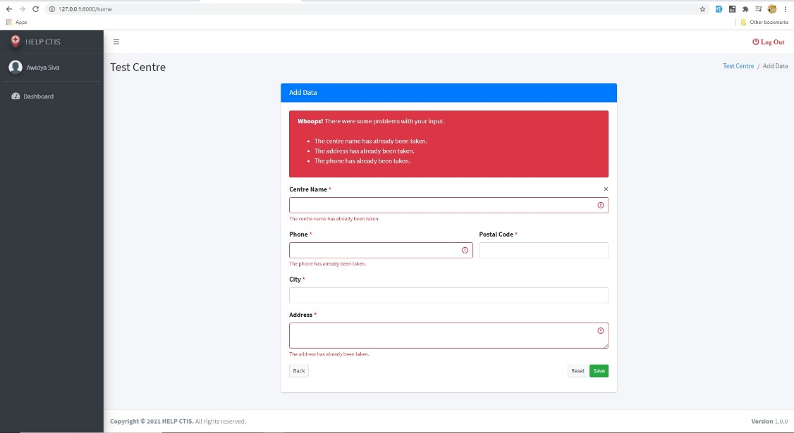

*Figure 23. Validation Register Test Centre (data already exists)*

* Empty input

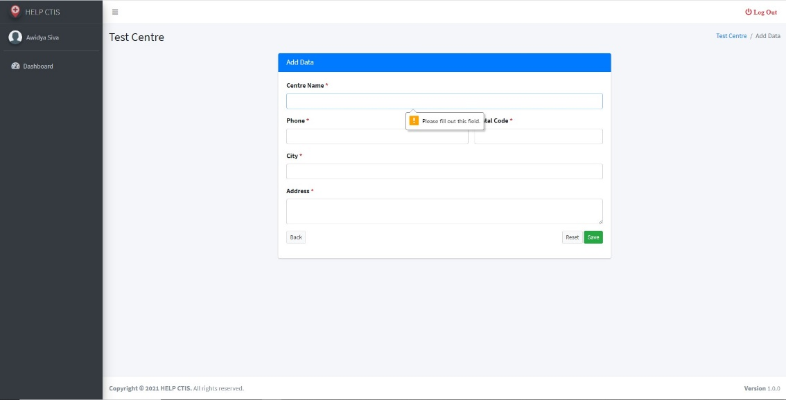

*Figure 24. Validation Register Test Centre (empty input)*

1. **Manage Test Kit Stock**

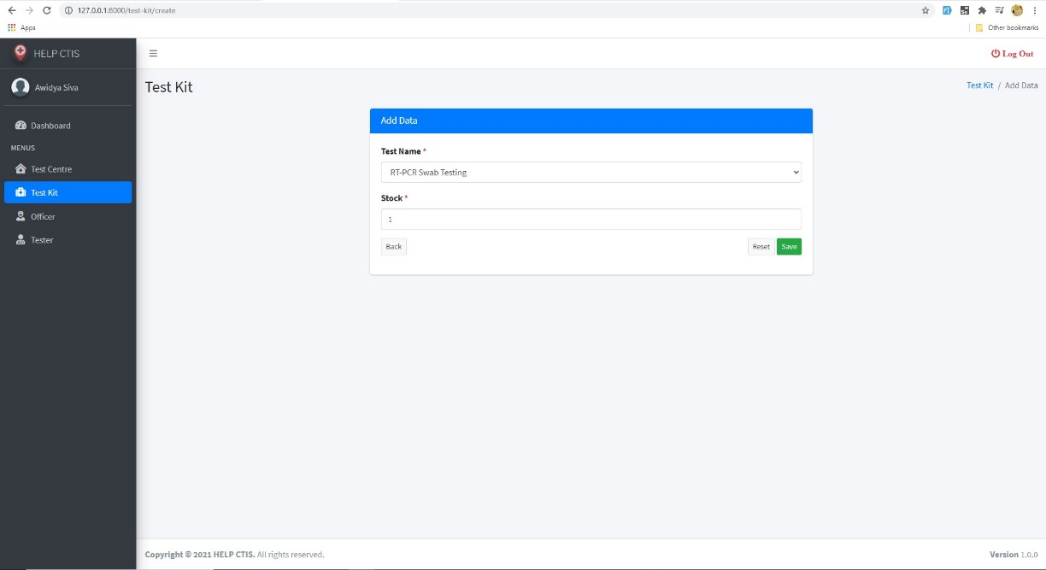

*Figure 25. Manage Test Kit Stock (add data)*

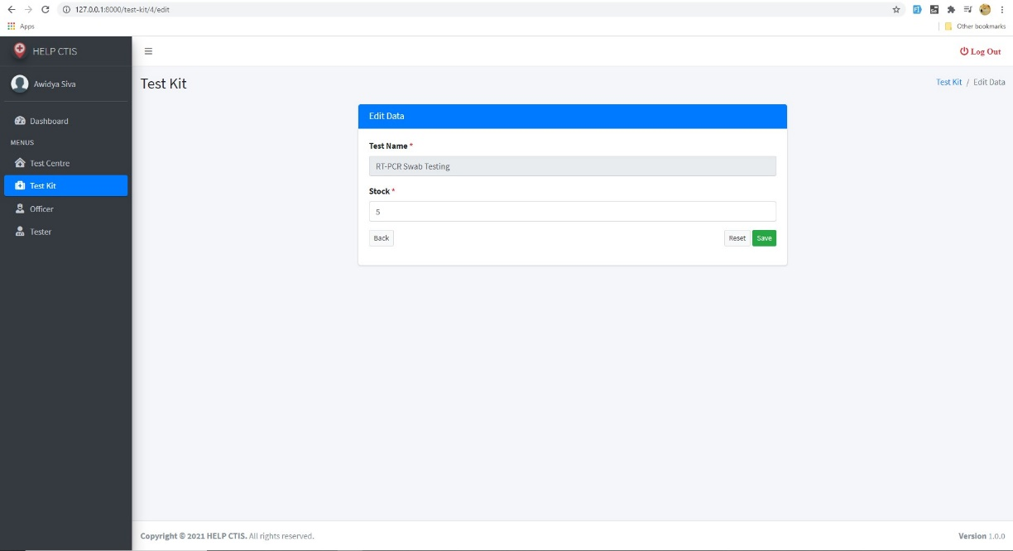

*Figure 26. Manage Test Kit Stock (edit)*

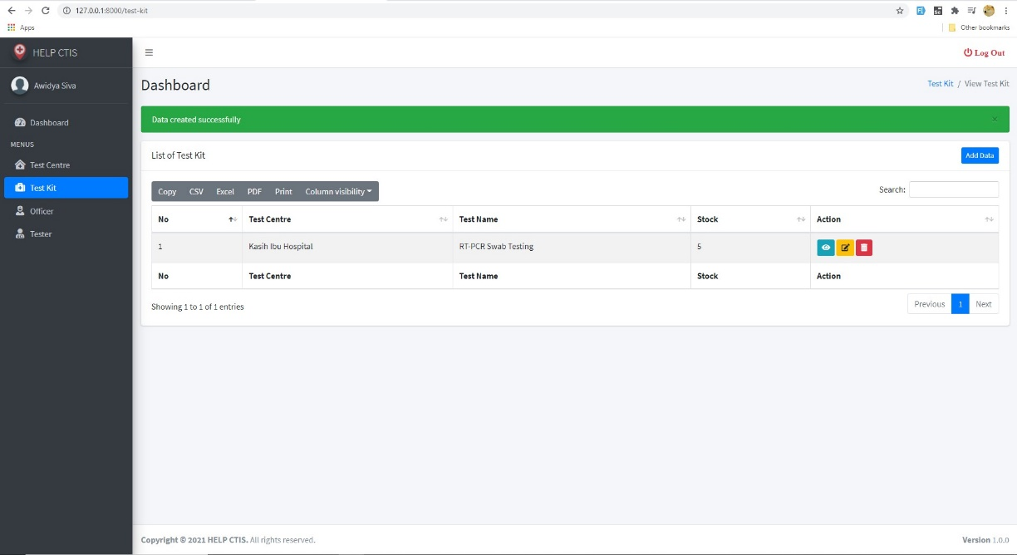

*Figure 27. Manage Test Kit Stock (success add data)*

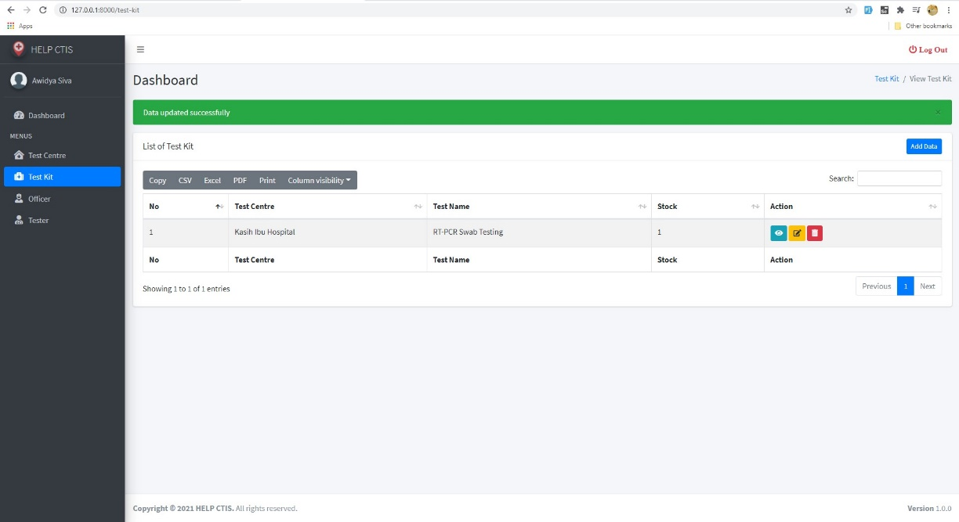

*Figure 28. Manage Test Kit Stock (success edit)*

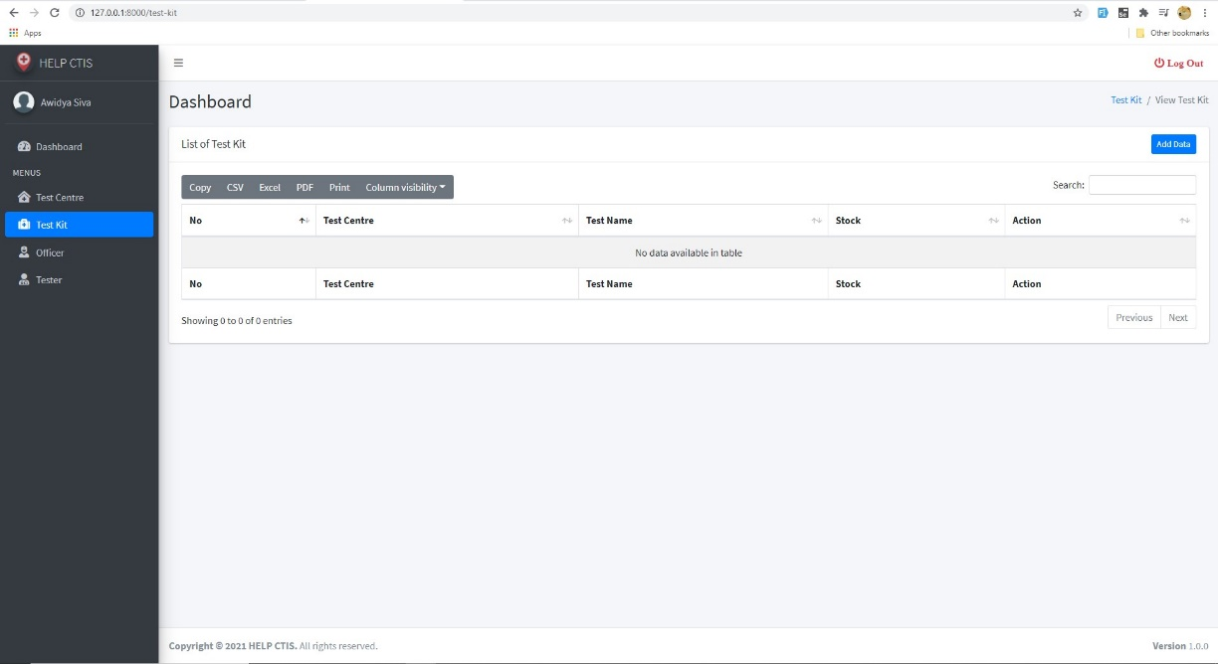

*Figure 29. Manage Test Kit Stock (view)*

**Validation for Manage Test Kit Stock**

* Adding same data

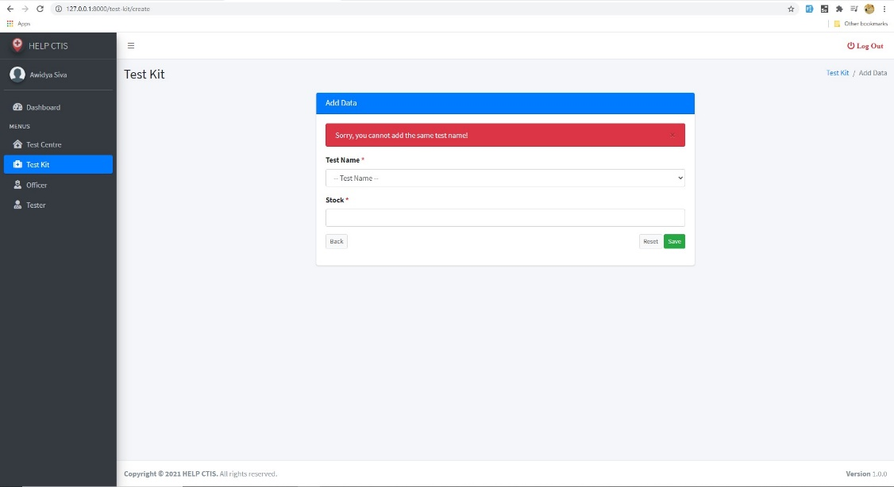

*Figure 30. Manage Test Kit Stock (adding same data)*

* Empty fill



*Figure 31. Manage Test Kit Stock (empty fill)*

* Input less than 1



*Figure 31. Manage Test Kit Stock (invalid input)*

1. **Record Officer**

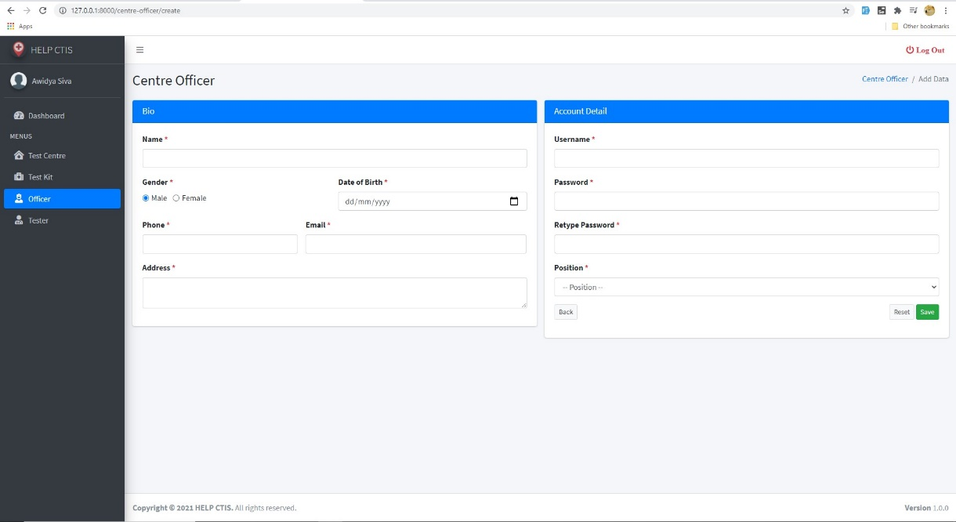

*Figure 32. Record Officer (add)*

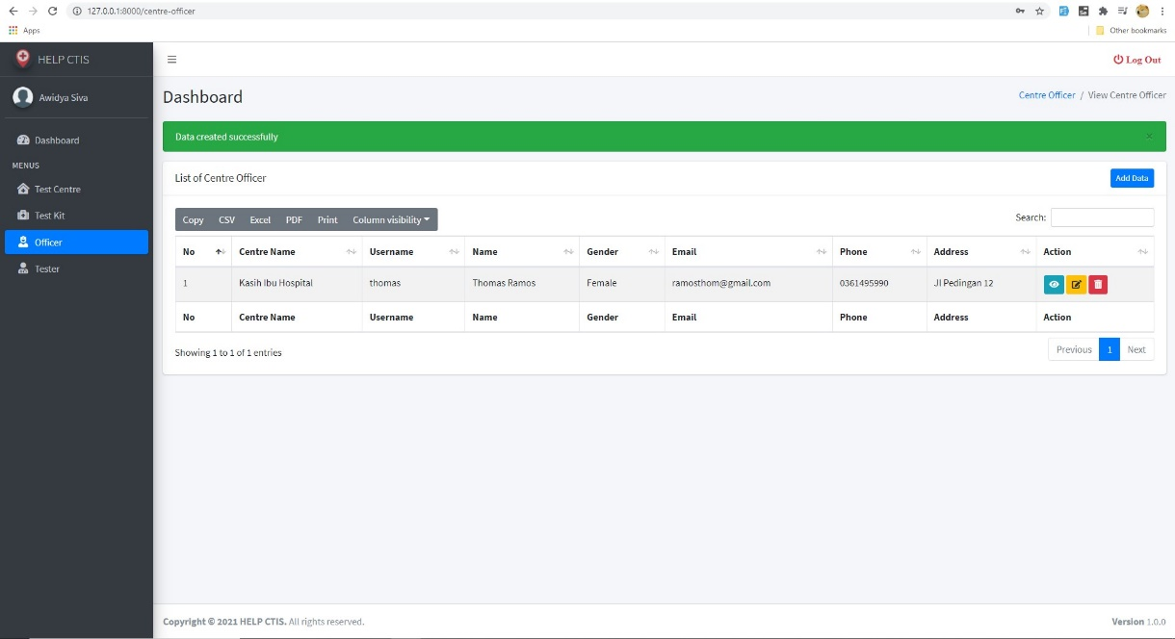

*Figure 33. Record Officer (add data success)*

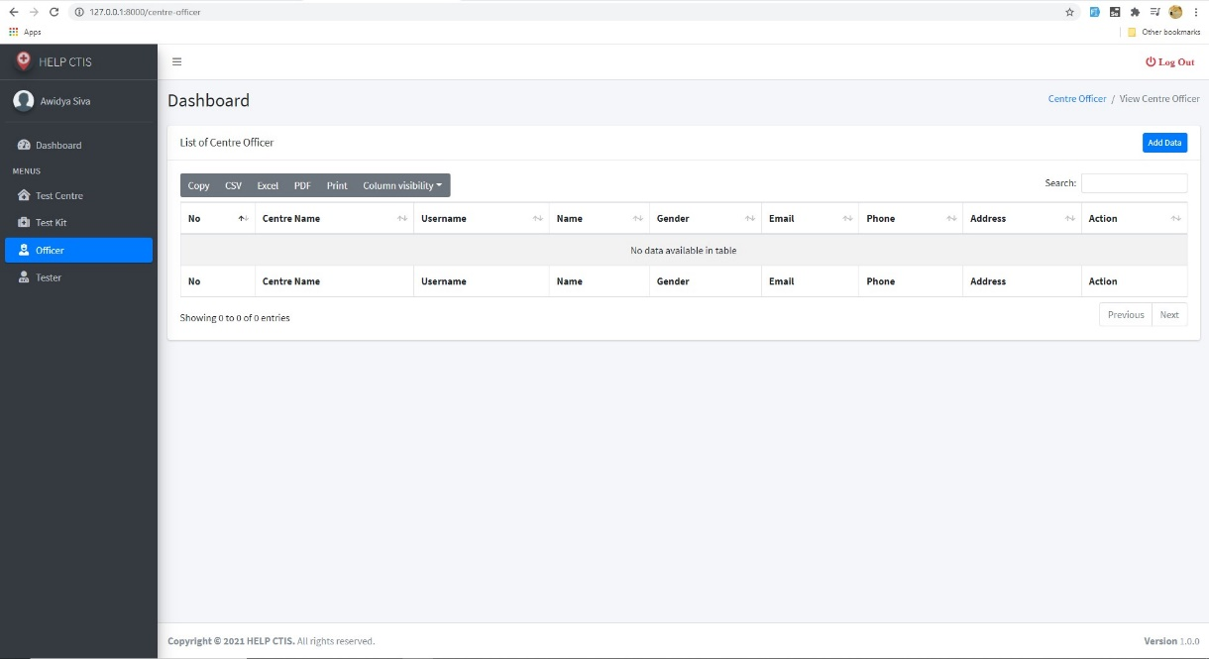

*Figure 34. Record Officer (view)*

**Validation for Record Officer**

* Data validation

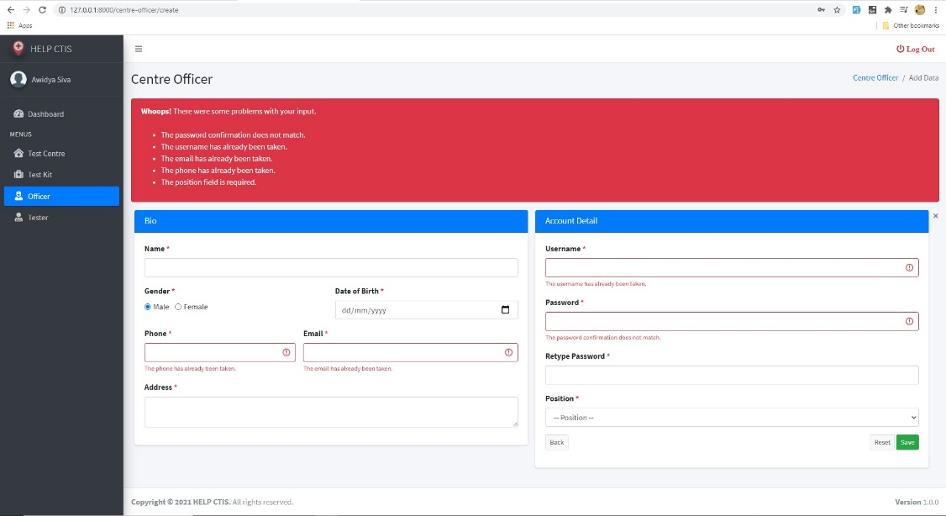

*Figure 35. Record Officer (data validation)*

* Empty input

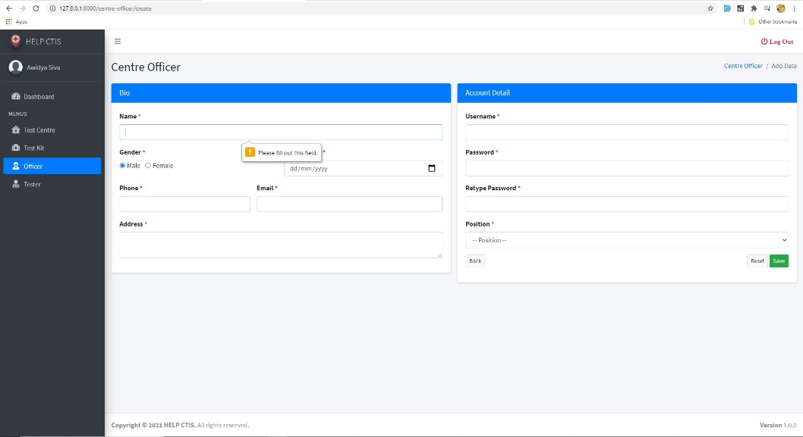

*Figure 36. Record Officer (empty input)*

1. **Record Tester**

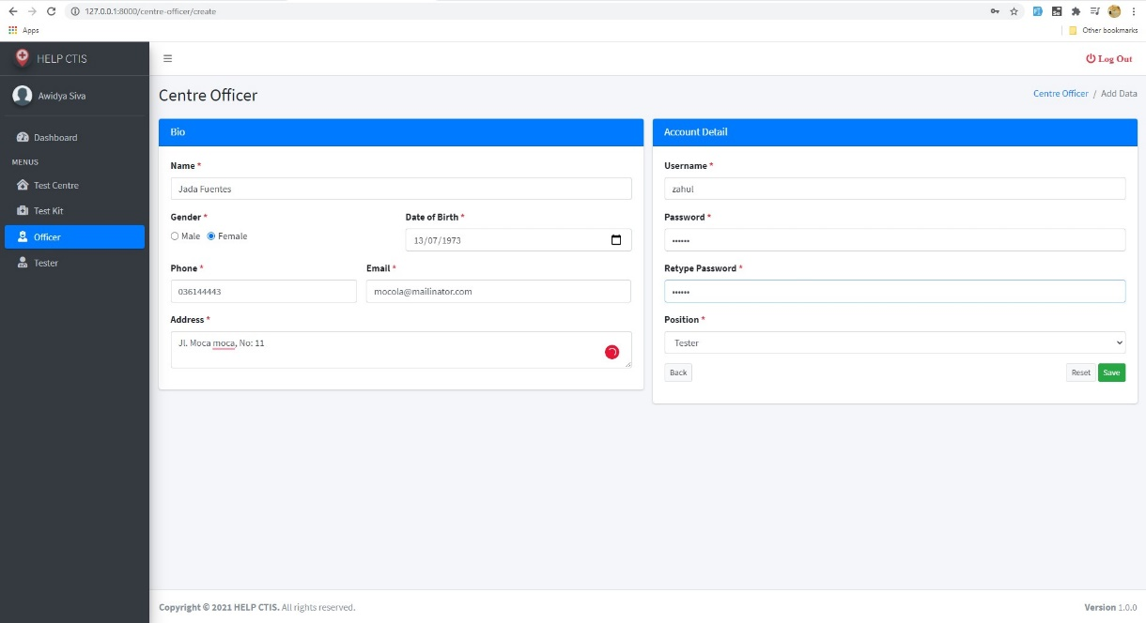

*Figure 37. Record Tester (add)*

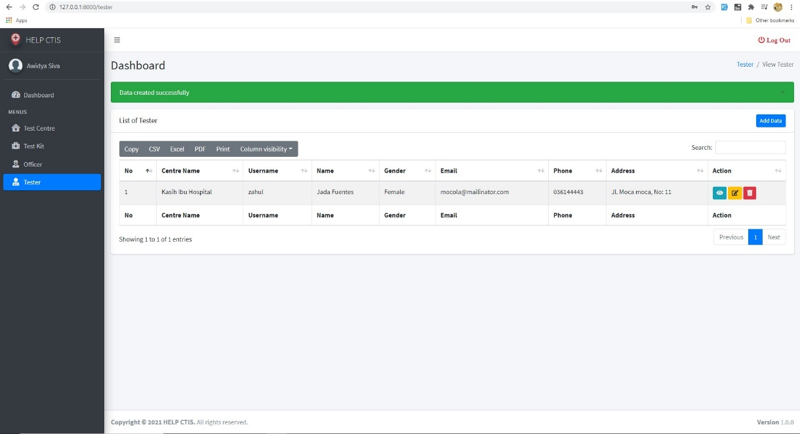

*Figure 38. Record Tester (success add)*

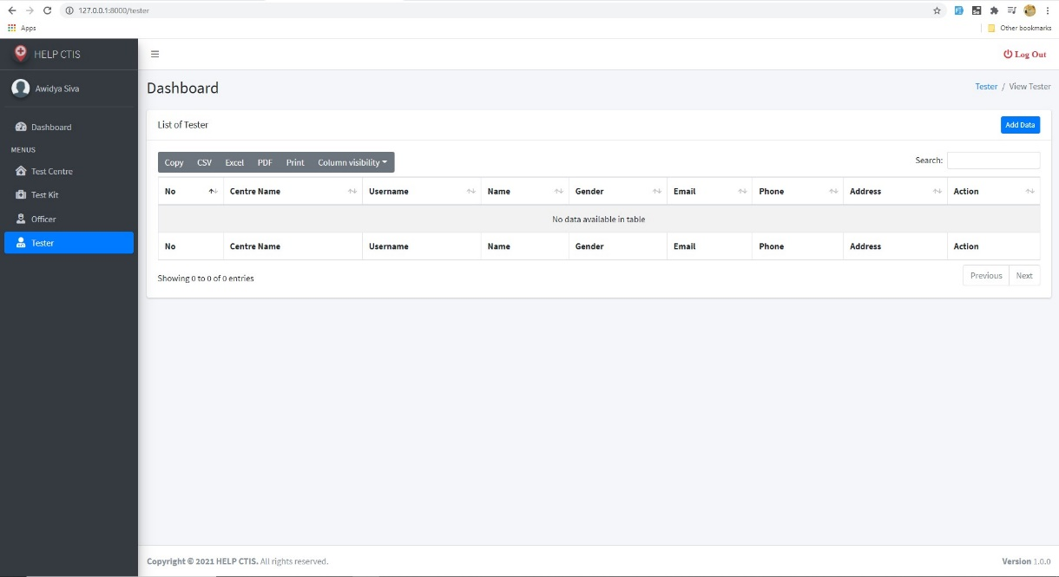

*Figure 39. Record Tester (view)*

**Validation for Record Tester**

* Data validation



*Figure 40. Record Tester (data validation)*

* Empty input

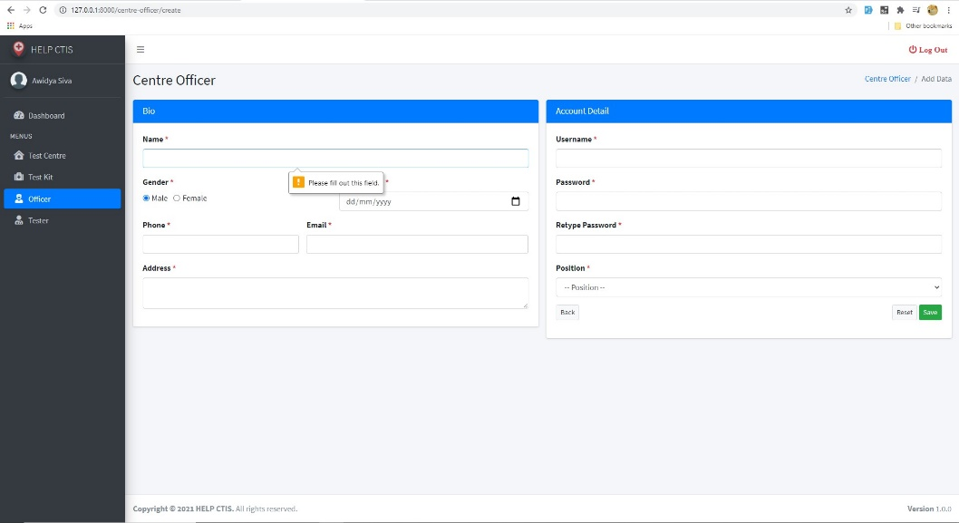

*Figure 41. Record Officer (empty input)*

1. **Record Patient**

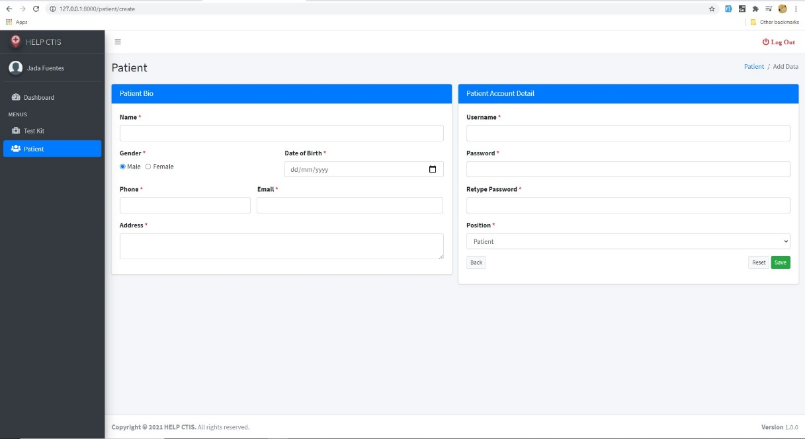

*Figure 42. Record Patient (add)*

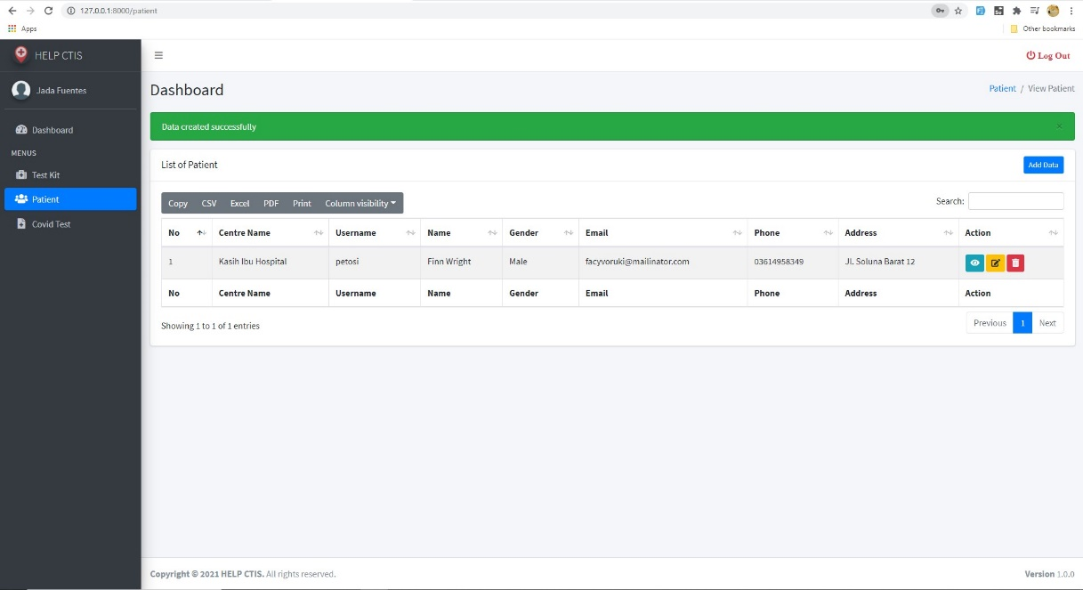

*Figure 43. Record Patient (success add)*



*Figure 44. Record Patient (view)*

**Validation for Record Patient**

* Data validation

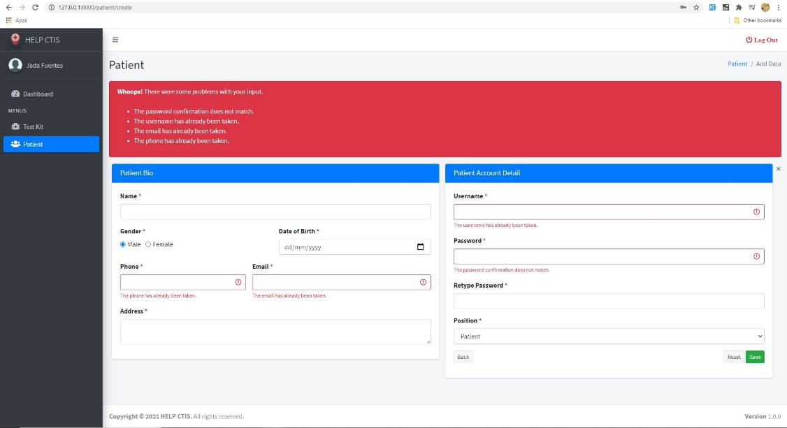

*Figure 45. Record Patient (data validation)*

* Empty input

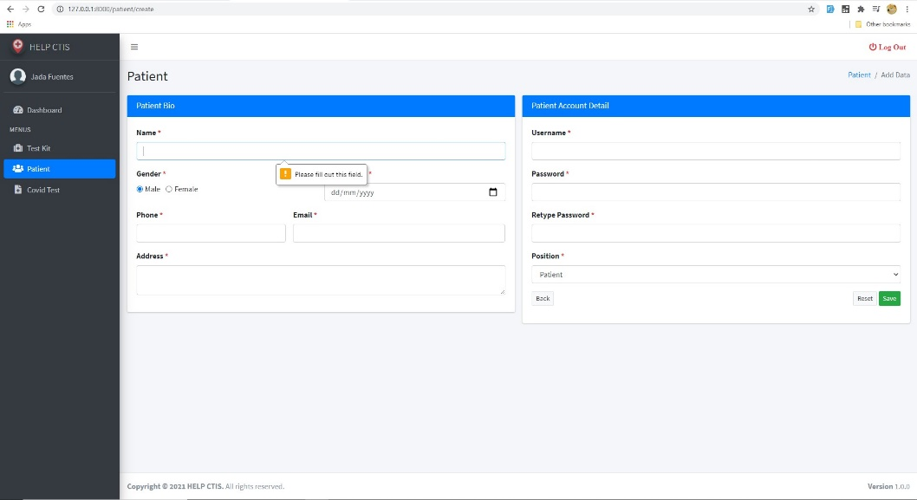

*Figure 46. Record Patient (empty input)*

1. **Record New Test**

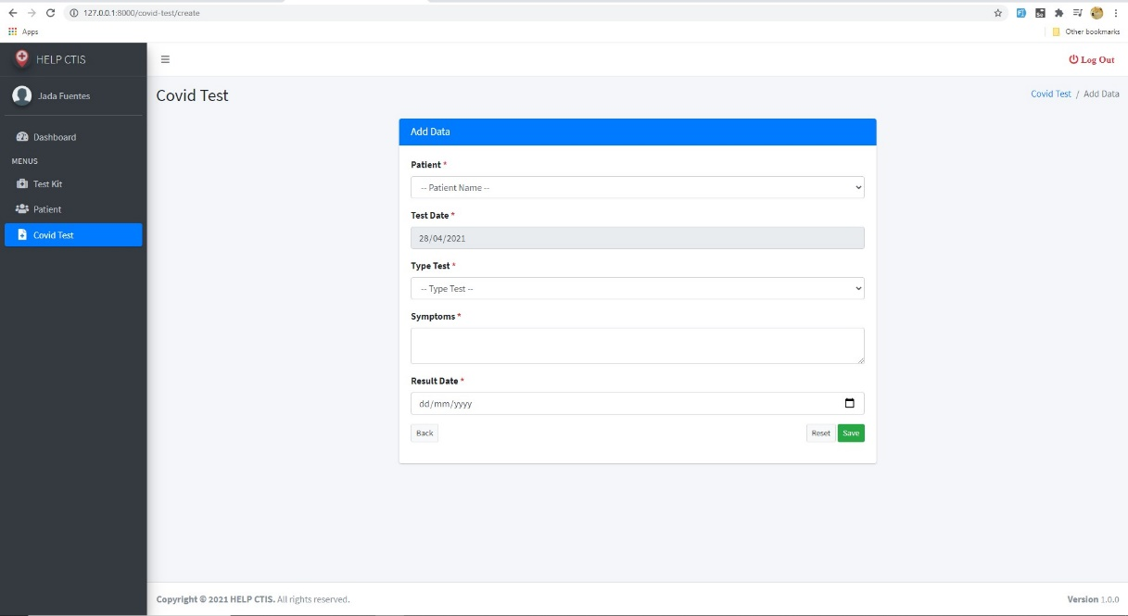

*Figure 47. Record New Test (add)*

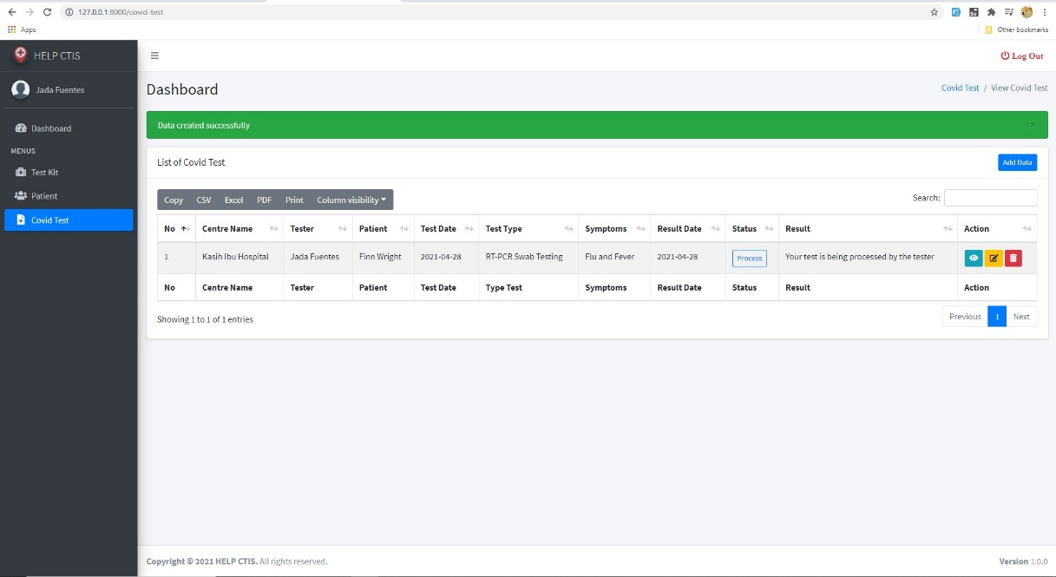

*Figure 48. Record New Test (success add)*

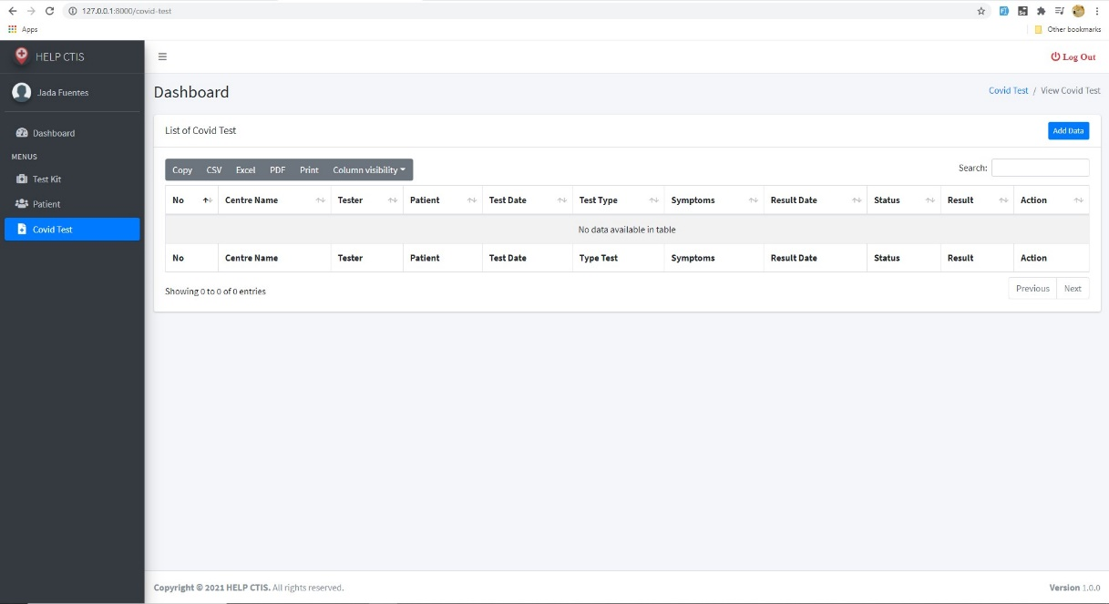

*Figure 49. Record New Test (success view )*

**Validation for Record New Test**

* Current day

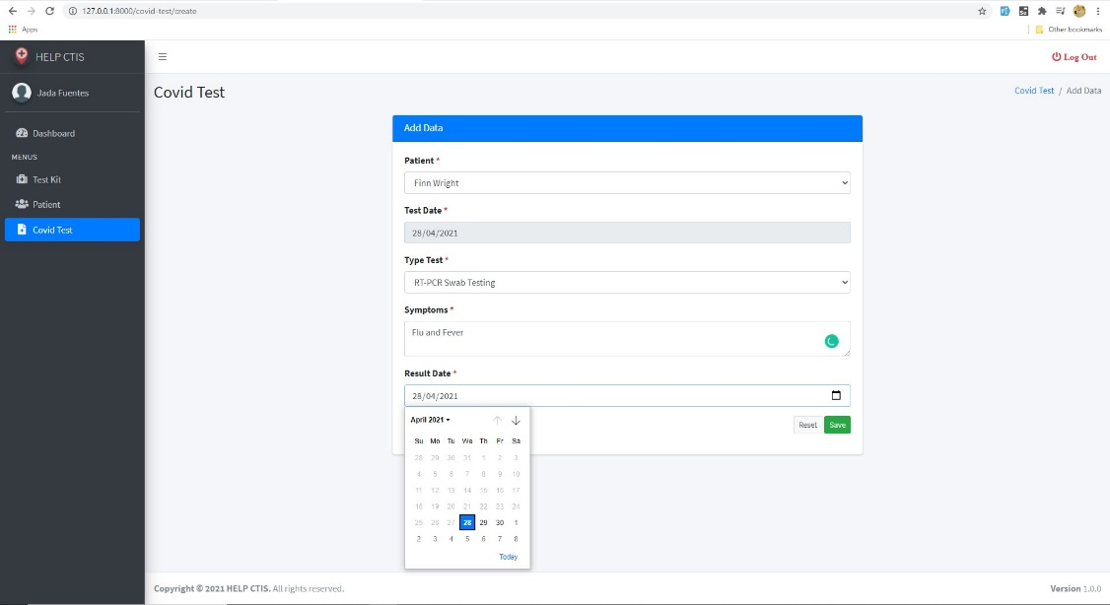

*Figure 50. Record New Test (current day)*

* Stock empty

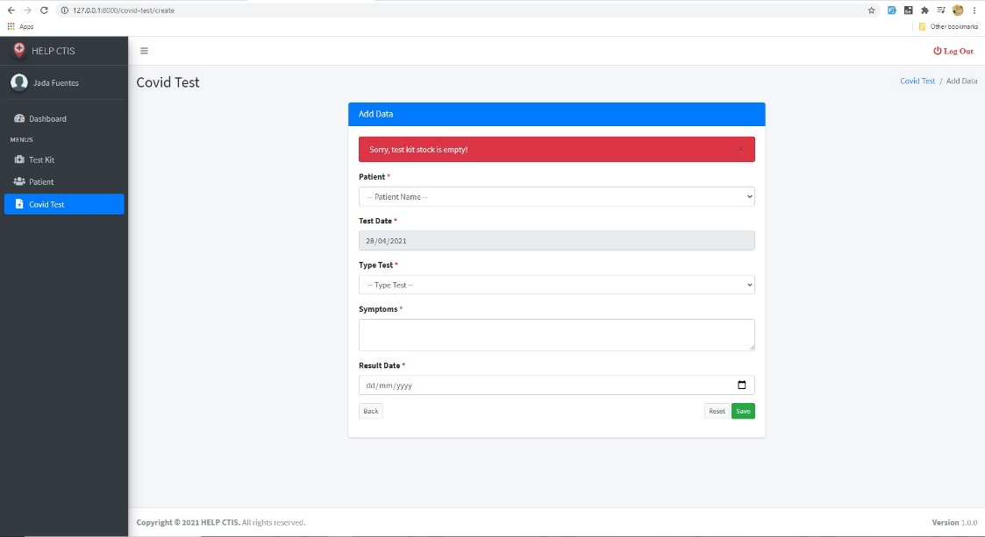

*Figure 51. Record New Test (stock empty)*

1. **Update Test Result**

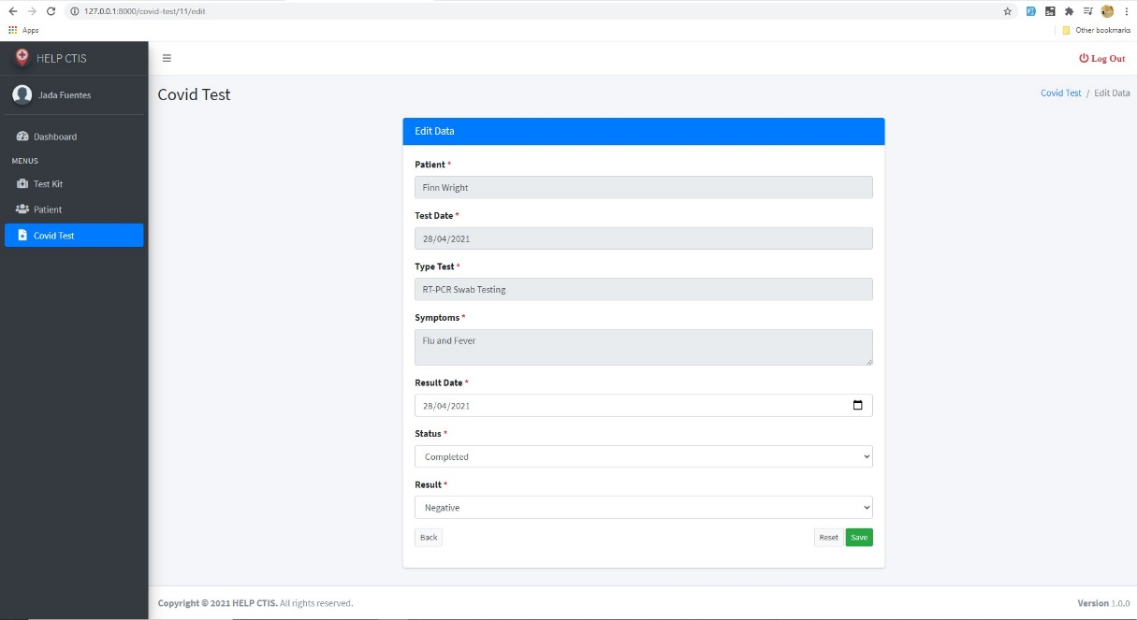

*Figure 52. Update Test Result (edit)*

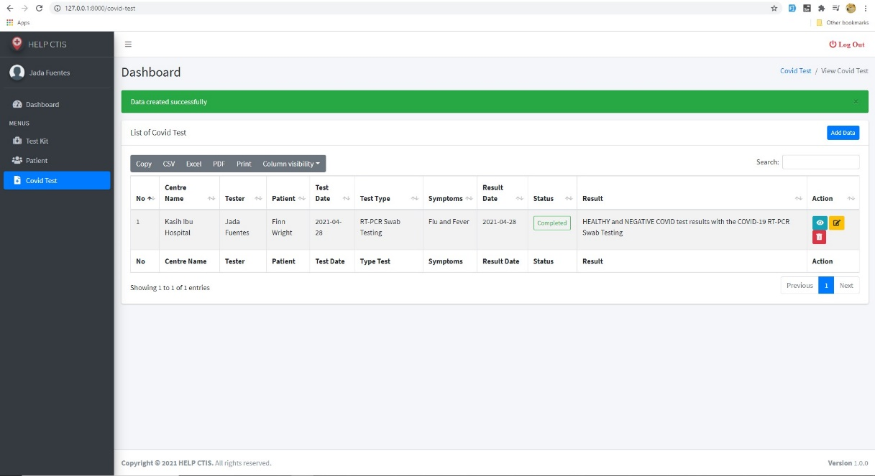

*Figure 53. Update Test Result (success edit)*

**Validation for Update Test Result**

* Current day

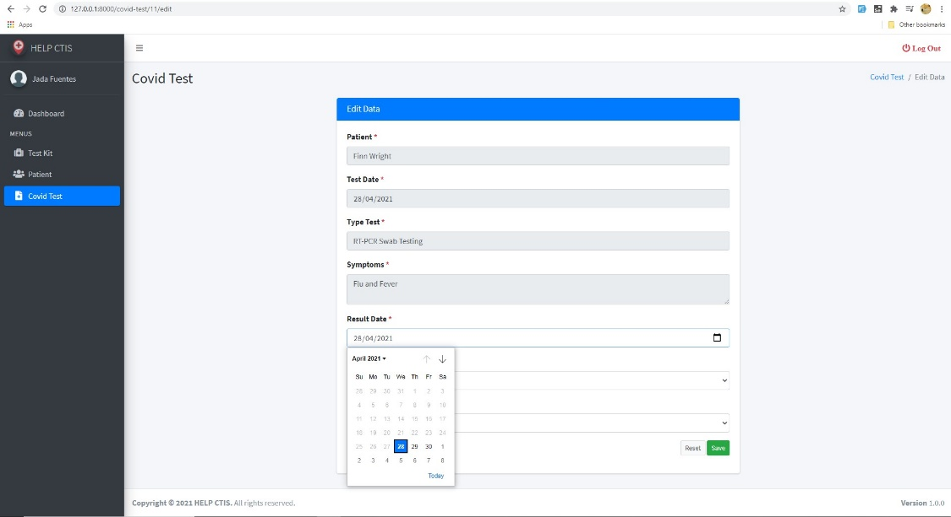

*Figure 54. Update Test Result (current day)*

1. **Generate Test Report**

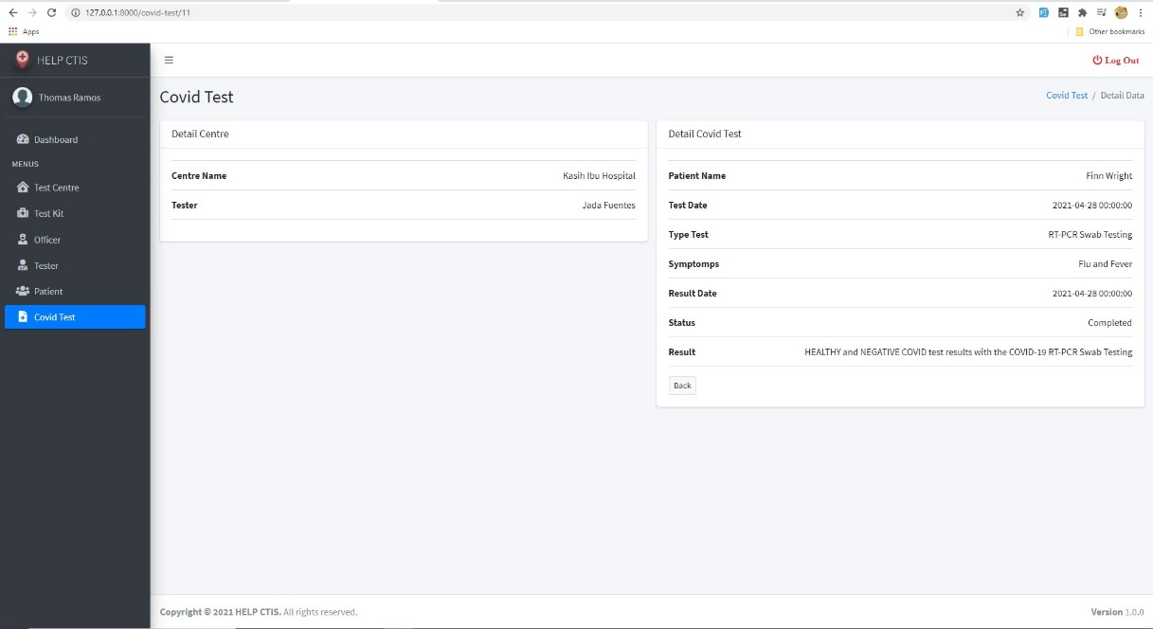

*Figure 55. Generate Test Report (show detail)*

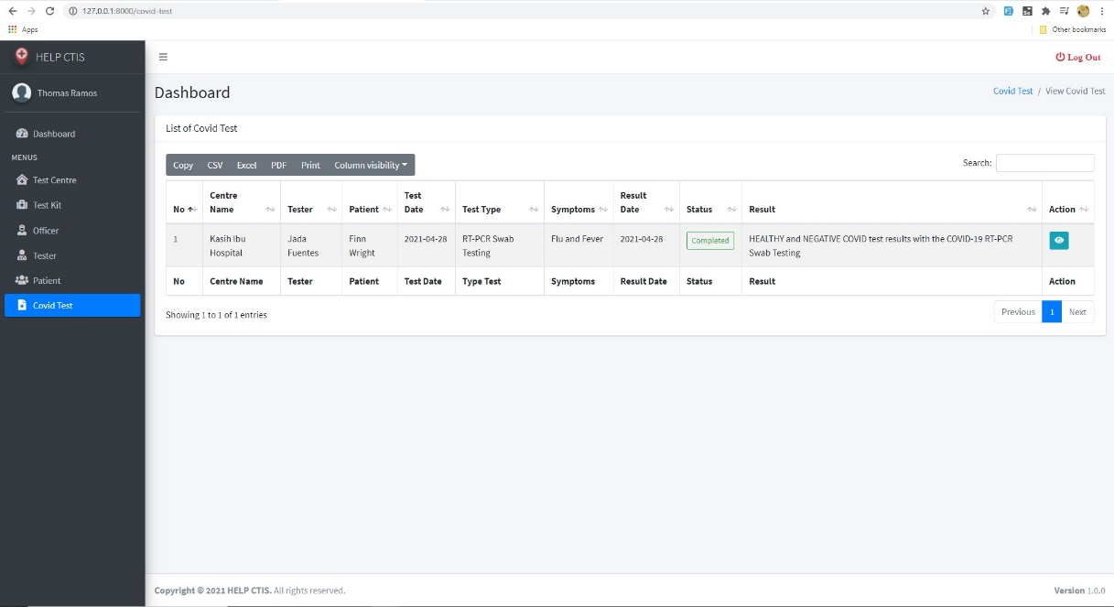

*Figure 56. Generate Test Report (view)*

1. **View Test Kit**

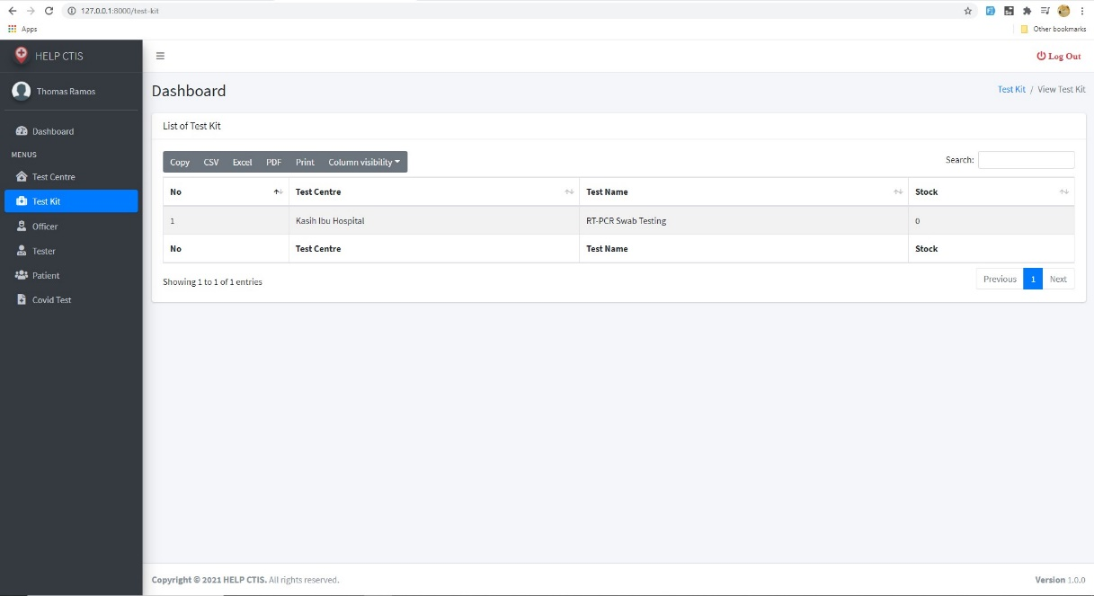

*Figure 57. View Test Kit*

1. **View Test Centre Officer**

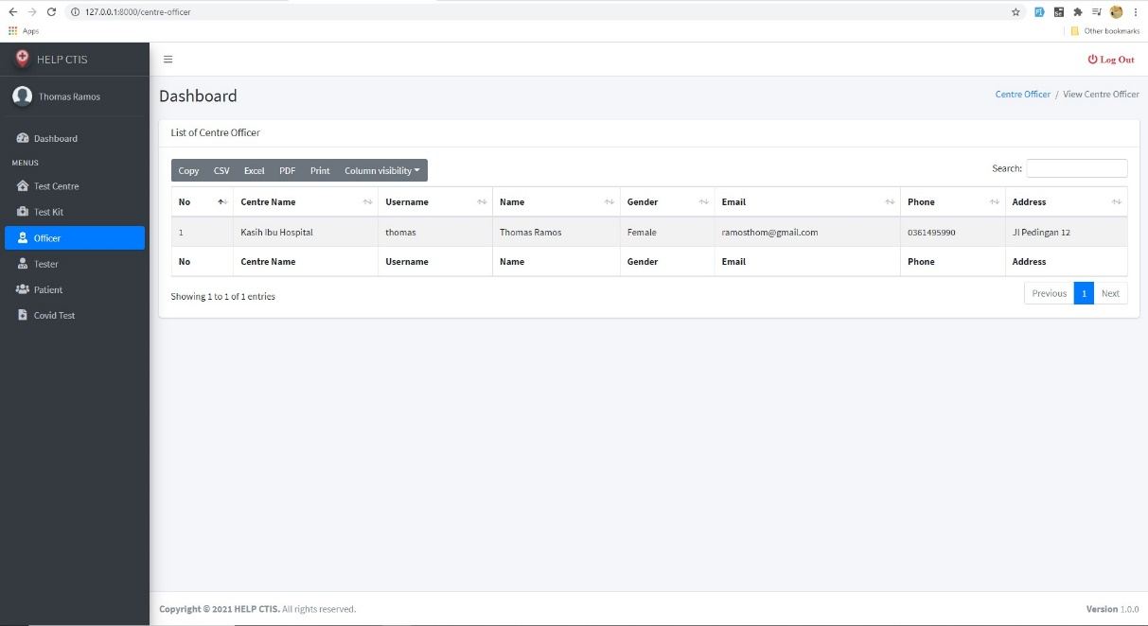

*Figure 58. View Test Centre Officer*

1. **View Testing History**

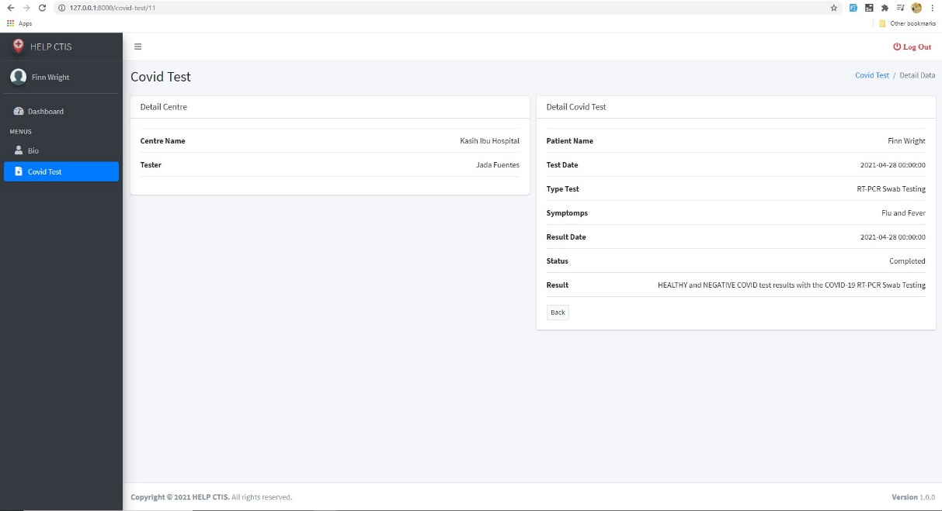

*Figure 59. View Testing History (show detail)*

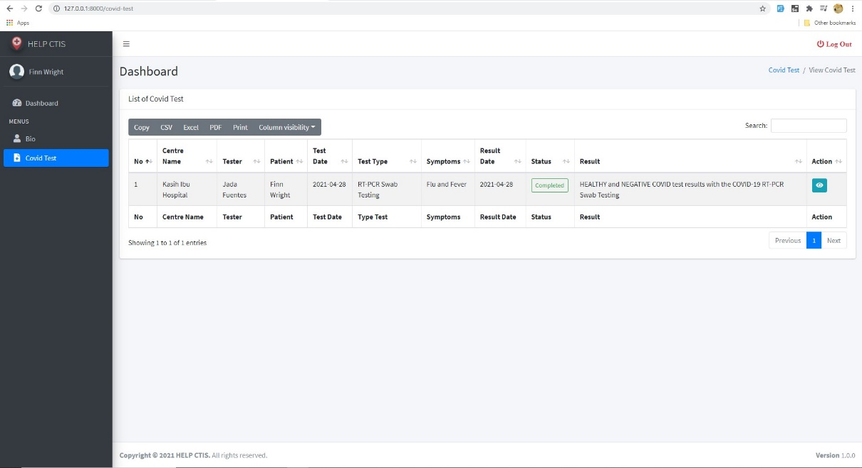

*Figure 60. View Testing History (history)*

1. **Logout**

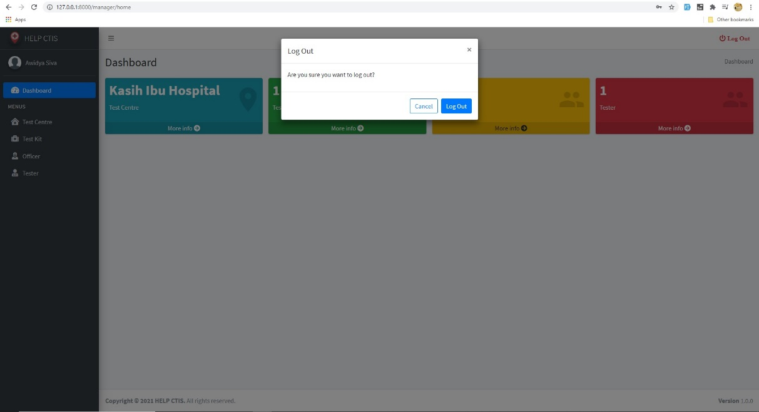

*Figure 61. Logout*

1. **Dashboard Manager**

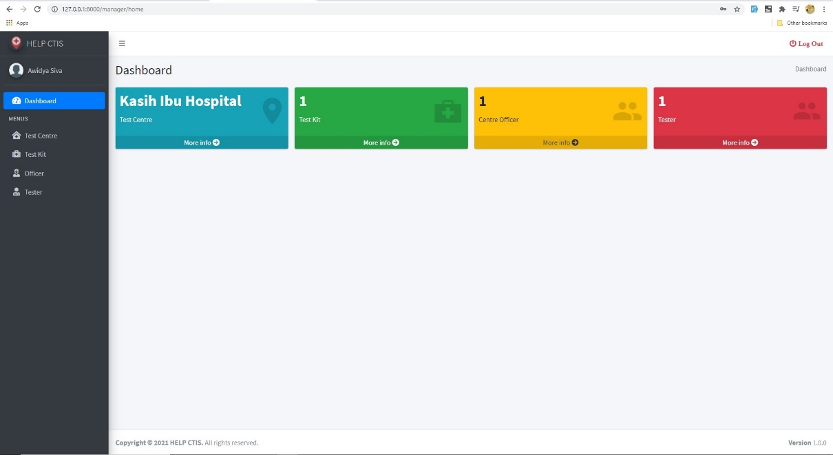

*Figure 62. Dashboard Manager*

1. **Dashboard Officer**

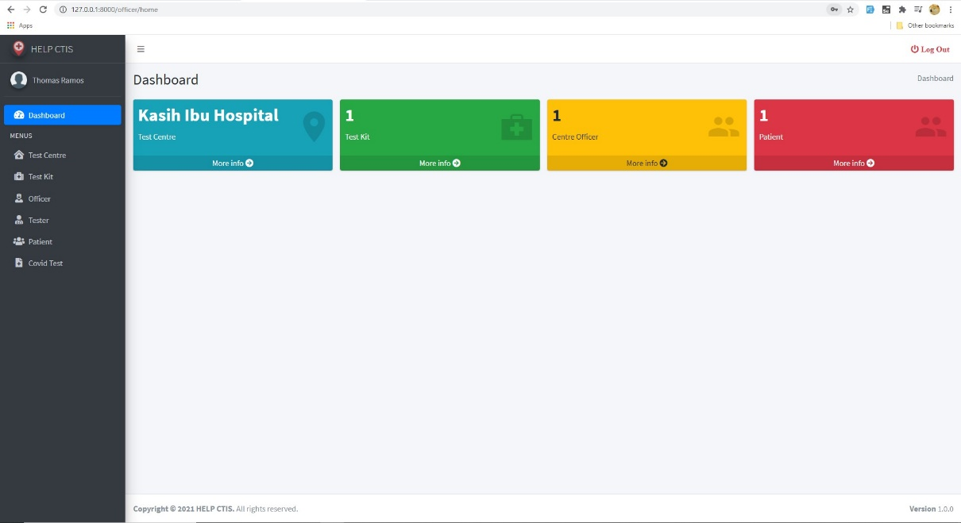

*Figure 63. Dashboard Officer*

1. **Dashboard Patient**

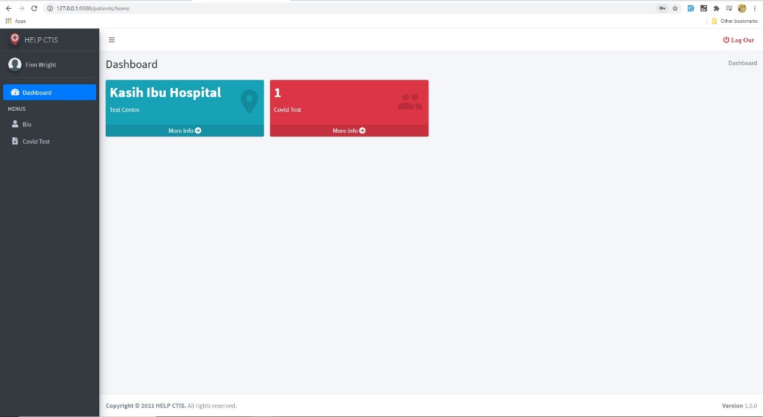

*Figure 64. Dashboard Patient*

1. **Dashboard Tester**

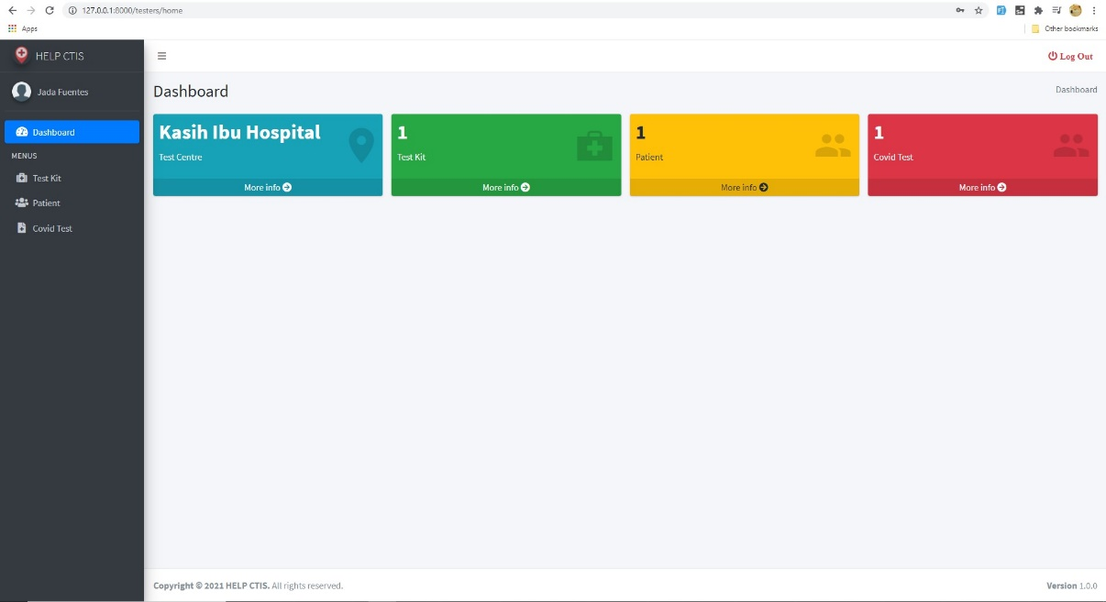

*Figure 65. Dashboard Tester*

1. **Index**

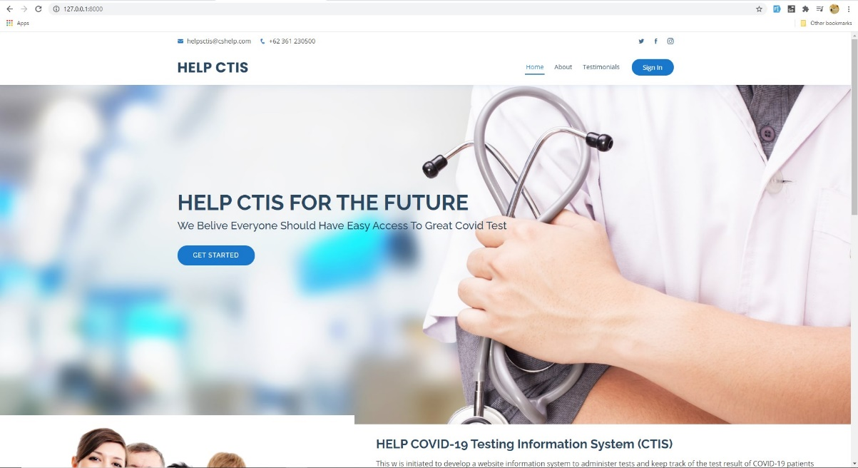

*Figure 66. Index Page (1)*

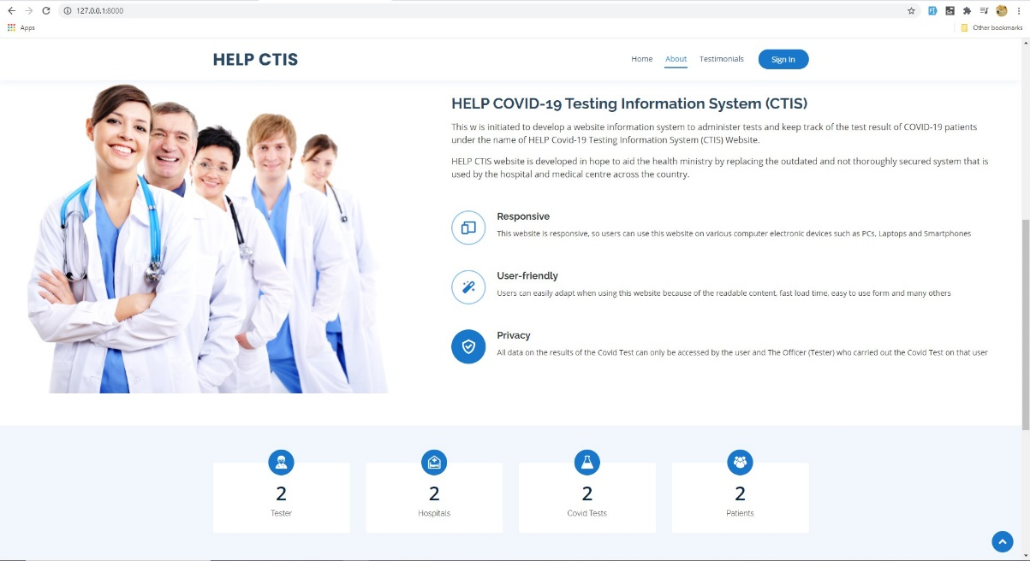

*Figure 67. Index Page (2)*



*Figure 68. Index Page (3)*

* 1. **Test Objectives**

The test objectives of the testing for the result of the first iteration of our project are to test the three use cases developed in this iteration based on the functional and non-functional requirements. Here is the list of the objectives that have to be fulfilled for the first iteration testing of this project:

* The system can be used on various computer devices such as PCs, laptops and smartphones
* The user interface runs according to its function, from buttons, links, forms, pages according to the role / position of the user
* The system can direct users to their dashboards when logged in based on their position
* All users can end their session via the logout process
* Manager can Register Test Center data
* Manager can Manage Test Kit Stock
* Manager can record Test Centre Officer
* Manager can record Tester
* Tester can Record Patient
* Tester can Record New Test
* Tester can Update Test Result
* Test Centre Officer can Generate Test Report
* Test Centre Officer can View Test Kit
* Test Centre Officer can View Centre Officer
* Patient can View Testing History
  1. **Test Plan**

|  |  |  |  |
| --- | --- | --- | --- |
| Type of Testing | Strategy/Approach | Tools (if any) | Schedule |
| Unit Testing   * Login * Register Test Centre * View Testing History * Record Patient * Record New Test * Update Test Result * Generate Test Report * View Test Kit * View Test Centre Officer * Manage Test Kit Stock * Record Tester * Record Officer * Logout | Black Box | PHP Storm | From gantt chart  4/5/21 – 4/6/21 |
| Integration Testing | Black Box | PHP Storm | From gantt chart  4/7/21 – 4/7/21 |
| Functional Testing | Black Box | PHP Storm | From gantt chart  4/7/21 – 4/7/21 |
| Non-Functional Testing | Black Box | Google Chrome | From gantt chart  4/8/21 – 4/8/21 |

* 1. **Test Cases**
  2. **Unit Testing**

**Prepared by: Ida Bagus Gede Awidya Andika**

|  |  |  |  |  |
| --- | --- | --- | --- | --- |
| Test ID | R-001 | | | |
| Use Case | Login | | | |
| Test Description | Allow User to login to the system | | | |
| Source Code | public function login(Request $request)  {  $input = $request->all();  $this->validate($request, [  'username' => 'required',  'password' => 'required',  ]);  $fieldType = filter_var($request->username, FILTER_VALIDATE_EMAIL) ? 'email' : 'username';  if(auth()->attempt(array($fieldType => $input['username'], 'password' => $input['password']))){  if (auth()->user()->position == 'manager')  {  return redirect()->route('manager-home');  }  else if(auth()->user()->position == 'officer')  {  return redirect()->route('officer-home');  }  else if(auth()->user()->position == 'tester')  {  return redirect()->route('tester-home');  }  else if(auth()->user()->position == 'patient')  {  return redirect()->route('patient-home');  }  else  {  return redirect()->route('home');  }  }else{  return redirect()->route('login')  ->with('error','Email or Username and Password are incorrect.');  }  } | | | |
|  | Test Data | Expected Output | Actual Output | Remark(s) |
| Test Case 1: | Username :  Password: | A warning notification will be displayed | A warning notification will be displayed | Pass |
| Test Case 2: | Username: manager  Password: manager | Directed to the Manager dashboard page | Directed to the Manager dashboard page | Pass |
| Test Case 3: | Username: tester  Password: tester | Directed to the Tester dashboard page | Directed to the Tester dashboard page | Pass |
| Test Case 4: | Username: officer  Password: officer | Directed to the Officer dashboard page | Directed to the Officer dashboard page | Pass |
| Test Case 5: | Username: patient  Password: patient | Directed to the Patient dashboard page | Directed to the Patient dashboard page | Pass |
| Test Case 6: | Username: user  Password: manager | A warning message that user input wrong Email or Username and Password are incorrect will be notify | A warning message that user input wrong Email or Username and Password are incorrect will be notify | Pass |

|  |  |  |  |  |
| --- | --- | --- | --- | --- |
| Test ID | R-002 | | | |
| Use Case | Register Test Centre | | | |
| Test Description | Allow Test Centre to be created and recorded for the Manager | | | |
| Source Code | public function store(Request $request)  {  $centre_name = auth()->user()->centre_name;  $data = DB::table('test_centres')->where('centre_name', $centre_name)->first();  if($data){  return redirect()->route('test-centre.index')  ->with('error', 'Sorry, you already created test centre');  }else{  $request->validate([  'centre_name' => 'required|unique:test_centres|max:32',  'address' => 'required|unique:test_centres|max:255',  'postal_code' => 'required|max:8',  'phone' => 'required|unique:test_centres|max:20',  'city' => 'required|max:32',  ]);  User::where('id', $request->user()['id'])->update([  'centre_name' => $request->centre_name  ]);  TestCentre::create($request->all());  return redirect()->route('test-centre.index')  ->with('success','Data created successfully');  }  } | | | |
|  | Test Data | Expected Output | Actual Output | Remark(s) |
| Test Case 1: | Test Centre Name:  Address:  Postal Code:  Phone:  City: | A warning notification will be displayed | A warning notification will be displayed | Pass |
| Test Case 2: | Test Centre Name: Bali Med  Address: Jl. Buana Kubu No. 65 DPS, BR/Link. Sari Buana  Postal Code: 80119  Phone: 085858839746  City: Denpasar | The data will be displayed on the Test Centre Dashboard | The data will be displayed on the Test Centre Dashboard | Pass |
| Test Case 3: | Test Centre Name: Bali Med  Address: Jl. Buana Kubu No. 65 DPS, BR/Link. Sari Buana  Postal Code: 80119  Phone: 085858839746  City: Denpasar | A warning message ‘Sorry, you already created test centre’ will be notify | A warning message ‘Sorry, you already created test centre’ will be notify | Pass |
| Test Case 4: | Test Centre Name: Bali Med  Address: Jl. Buana Kubu No. 65 DPS, BR/Link. Sari Buana  Postal Code: 80119  Phone: 085858839746  City: Denpasar | A warning message will be notify: - The centre name has already been taken - The address has already taken - The phone has already taken | A warning message will be notify: - The centre name has already been taken - The address has already taken - The phone has already taken | Pass |

|  |  |  |  |  |
| --- | --- | --- | --- | --- |
| Test ID | R-003 | | | |
| Use Case | Manage Test Kit Stock | | | |
| Test Description | Allow Test Centre Manager to add Test Kit or update Test Kit stock | | | |
| Source Code | public function store(Request $request)  {  $request->validate([  'centre_id' => 'required',  'test_name' => 'required',  'stock' => 'required|max:11',  ]);  $data = DB::table('test_kits')  ->join('test_centres', 'test_kits.centre_id', '=', 'test_centres.id')  ->join('users', 'test_centres.centre_name', '=', 'users.centre_name')  ->where('users.name', Auth::user()->name)  ->where('test_name', $request->test_name)  ->first();  if($data){  return redirect()->route('test-kit.create')  ->with('error','Sorry, you cannot add the same test name!');  }else{  TestKit::create($request->all());  return redirect()->route('test-kit.index')  ->with('success','Data created successfully');  }  }  public function update(Request $request, TestKit $testKit)  {  $request->validate([  'test_name' => 'required',  'stock' => 'required|max:11',  ]);  $testKit->update($request->all());  return redirect()->route('test-kit.index')  ->with('success','Data updated successfully');  } | | | |
|  | Test Data | Expected Output | Actual Output | Remark(s) |
| Test Case 1: | Test Name:  Stock: | A warning notification will be displayed | A warning notification will be displayed | Pass |
| Test Case 2: | Test Name: RT-PCR Swab Testing  Stock: 1 | The data will be displayed on the Test Kit menu | The data will be displayed on the Test Kit menu | Pass |
| Test Case 3: | Test Name: RT-PCR Swab Testing  Stock: 1 | A warning message ‘Sorry, you cannot add the same test name!’ will be notify | A warning message ‘Sorry, you cannot add the same test name!’ will be notify | Pass |
| Test Case 4: | Test Name: RT-PCR Swab Testing  Stock: 0 | A warning message ‘Value must be greater than or equal to 1’ will be notify | A warning message ‘Value must be greater than or equal to 1’ will be notify | Pass |

|  |  |  |  |  |
| --- | --- | --- | --- | --- |
| Test ID | R-004 | | | |
| Use Case | Record Officer | | | |
| Test Description | Allow Manager to record Officer | | | |
| Source Code | public function store(Request $request)  {  $request->validate([  'centre_name' => 'required',  'password' => ['required', 'string', 'confirmed', 'alpha_dash'],  'username' => 'required|unique:users|max:16|alpha_dash',  'name' => 'required|max:64',  'gender' => 'required',  'dob' => 'required',  'email' => 'required|unique:users|max:64',  'phone' => 'required|unique:users|max:20',  'address' => 'required|max:255',  'position' => 'required',  ]);  $request['password'] = bcrypt($request->password);  User::create($request->all());  if($request->position == 'tester'){  return redirect()->route('tester.index')  ->with('success','Data created successfully');  }else{  return redirect()->route('centre-officer.index')  ->with('success','Data created successfully');  }  } | | | |
|  | Test Data | Expected Output | Actual Output | Remark(s) |
| Test Case 1: | Name:  Gender:  Date of Birth:  Phone:  Email:  Address:  Username:  Password:  Retype Password:  Position: | A warning notification will be displayed | A warning notification will be displayed | Pass |
| Test Case 2: | Name: David Chris  Gender: Male  Date of Birth: 30/12/1990  Phone: 08181229403  Email: davidchris@gmail.com  Address: Jl. Danggala No: 05  Username: david  Password: officer  Retype Password: officer  Position: officer | The data will be displayed on the Test Centre Officer menu | The data will be displayed on Test Centre Officer menu | Pass |
| Test Case 3: | Name: David Chris  Gender: Male  Date of Birth: 30/12/1990  Phone: 08181229403  Email: davidchris@gmail.com  Address: Jl. Danggala No: 05  Username: david  Password: officer  Retype Password: asd  Position: | A warning message will be notify:   * The username has already been taken * The email has already been taken * The phone has already been taken * The password confirmation does not match * The position field is required | A warning message will be notify:   * The username has already been taken * The email has already been taken * The phone has already been taken * The password confirmation does not match * The position field is required | Pass |

|  |  |  |  |  |
| --- | --- | --- | --- | --- |
| Test ID | R-005 | | | |
| Use Case | Record Tester | | | |
| Test Description | Allow Manager to record Tester | | | |
| Source Code | public function store(Request $request)  {  $request->validate([  'centre_name' => 'required',  'password' => ['required', 'string', 'confirmed', 'alpha_dash'],  'username' => 'required|unique:users|max:16|alpha_dash',  'name' => 'required|max:64',  'gender' => 'required',  'dob' => 'required',  'email' => 'required|unique:users|max:64',  'phone' => 'required|unique:users|max:20',  'address' => 'required|max:255',  'position' => 'required',  ]);  $request['password'] = bcrypt($request->password);  User::create($request->all());  return redirect()->route('tester.index')  ->with('success','Data created successfully');  } | | | |
|  | Test Data | Expected Output | Actual Output | Remark(s) |
| Test Case 1: | Name:  Gender:  Date of Birth:  Phone:  Email:  Address:  Username:  Password:  Retype Password:  Position: | A warning notification will be displayed | A warning notification will be displayed | Pass |
| Test Case 2: | Name: Adena Dodson  Gender: Female  Date of Birth: 19/12/1997  Phone: 085473985765  Email: adenadodson@gmail.com  Address: Jl. Kebo Iwa Selatan, No: 1B  Username: adena  Password: tester  Retype Password: tester  Position: tester | The data will be displayed on the Tester menu | The data will be displayed on Tester menu | Pass |
| Test Case 3: | Name: Adena Dodson  Gender: Female  Date of Birth: 19/12/1997  Phone: 085473985765  Email: adenadodson@gmail.com  Address: Jl. Kebo Iwa Selatan, No: 1B  Username: adena  Password: tester  Retype Password: asd  Position: tester | A warning message will be notify:   * The username has already been taken * The email has already been taken * The phone has already been taken * The password confirmation does not match | A warning message will be notify:   * The username has already been taken * The email has already been taken * The phone has already been taken * The password confirmation does not match | Pass |

|  |  |  |  |  |
| --- | --- | --- | --- | --- |
| Test ID | R-006 | | | |
| Use Case | Record Patient | | | |
| Test Description | Allow Tester to record Patient | | | |
| Source Code | public function store(Request $request)  {  $request->validate([  'centre_name' => 'required',  'password' => ['required', 'string', 'confirmed', 'alpha_dash'],  'username' => 'required|unique:users|max:16|alpha_dash',  'name' => 'required|max:64',  'gender' => 'required',  'dob' => 'required',  'email' => 'required|unique:users|max:64',  'phone' => 'required|unique:users|max:20',  'address' => 'required|max:255',  'position' => 'required',  ]);  $request['password'] = bcrypt($request->password);  User::create($request->all());  return redirect()->route('patient.index')  ->with('success','Data created successfully');  } | | | |
|  | Test Data | Expected Output | Actual Output | Remark(s) |
| Test Case 1: | Name:  Gender:  Date of Birth:  Phone:  Email:  Address:  Username:  Password:  Retype Password:  Position: | A warning notification will be displayed | A warning notification will be displayed | Pass |
| Test Case 2: | Name: Surya Ramadan  Gender: Male  Date of Birth: 03/11/1975  Phone: 081575567589  Email: suryaramadan@gmail.com  Address: Jl. Pattimura Permai, No: 22  Username: surya  Password: patient  Retype Password: patient  Position: patient | The data will be displayed on the Patient menu | The data will be displayed on Patient menu | Pass |
| Test Case 3: | Name: Surya Ramadan  Gender: Male  Date of Birth: 03/11/1975  Phone: 081575567589  Email: suryaramadan@gmail.com  Address: Jl. Pattimura Permai, No: 22  Username: surya  Password: patient  Retype Password: asd  Position: patient | A warning message will be notify:   * The username has already been taken * The email has already been taken * The phone has already been taken * The password confirmation does not match | A warning message will be notify:   * The username has already been taken * The email has already been taken * The phone has already been taken * The password confirmation does not match | Pass |

|  |  |  |  |  |
| --- | --- | --- | --- | --- |
| Test ID | R-007 | | | |
| Use Case | Record New Test | | | |
| Test Description | Allow Tester to record Covid Test data | | | |
| Source Code | public function store(Request $request)  {  $request->validate([  'officer_name' => 'required|max:64',  'patient_name' => 'required|max:64',  'test_date' => 'required',  'test_name' => 'required',  'symptoms' => 'required|max:255',  'result_date' => 'required',  ]);  $data = DB::table('test_kits')  ->join('test_centres', 'test_kits.centre_id', '=', 'test_centres.id')  ->where('test_centres.centre_name', Auth::user()->centre_name)  ->where('test_kits.test_name', $request->test_name)  ->where('test_kits.stock', '>' ,'0')  ->first();  if($data){  TestKit::where('test_name', $request->test_name)->decrement('stock', 1);  }else{  return redirect()->route('covid-test.create')  ->with('error','Sorry, test kit stock is empty!');  }  CovidTest::create($request->all());  return redirect()->route('covid-test.index')  ->with('success','Data created successfully');  } | | | |
|  | Test Data | Expected Output | Actual Output | Remark(s) |
| Test Case 1: | Patient:  Test Date:  Type Test:  Symptoms:  Result Date: | A warning notification will be displayed | A warning notification will be displayed | Pass |
| Test Case 2: | Patient: Surya Ramadan  Test Date: 27/04/2021  Type Test: RT-PCR Swab Testing  Symptoms: Flu and Fever Result Date: 28/04/2021 | The data will be displayed on the Covid Test menu | The data will be displayed on Covid Test menu | Pass |
| Test Case 3: | Patient: Surya Ramadan  Test Date: 27/04/2021  Type Test: RT-PCR Swab Testing  Symptoms: Flu and Fever Result Date: 28/04/2021 | A warning message ‘Sorry, test kit stock is empty!’ will be notify | A warning message ‘Sorry, test kit stock is empty!’ will be notify | Pass |

|  |  |  |  |  |
| --- | --- | --- | --- | --- |
| Test ID | R-008 | | | |
| Use Case | Update Test Result | | | |
| Test Description | Allow Tester to update Patient’s test result and status | | | |
| Source Code | public function update(Request $request, CovidTest $covidTest)  {  $request->validate([  'symptoms' => 'required|max:255',  'result_date' => 'required',  'status' => 'required',  'result' => 'required|max:100',  ]);  $covidTest->update($request->all());  return redirect()->route('covid-test.index')  ->with('success','Data created successfully');  } | | | |
|  | Test Data | Expected Output | Actual Output | Remark(s) |
| Test Case 1: | Patient:  Test Date:  Type Test:  Symptoms:  Result Date:  Status:  Result: | A warning notification will be displayed | A warning notification will be displayed | Pass |
| Test Case 2: | Patient: Surya Ramadan  Test Date: 27/04/2021  Type Test: RT-PCR Swab Testing  Symptoms: Flu and Fever Result Date: 28/04/2021  Status: Completed Result: HEALTHY and NEGATIVE COVID test results with the COVID-19 Antibody Testing | The data will be displayed on the Covid Test menu | The data will be displayed on Covid Test menu | Pass |

**Prepared by: I Made Siva Aditya Surya**

|  |  |  |  |  |
| --- | --- | --- | --- | --- |
| Test ID | R-009 | | | |
| Use Case | View Testing History | | | |
| Test Description | Allow Patient to view their testing history | | | |
| Source Code | public function index()  {  $data = DB::table('covid_tests')  ->join('users', 'covid_tests.officer_name', '=', 'users.name')  ->join('test_centres', 'test_centres.centre_name', '=', 'users.centre_name')  ->where('test_centres.centre_name', Auth::user()->centre_name)  ->select(['covid_tests.*', 'test_centres.centre_name'])->paginate(5);  return view('covid-test.index', compact( 'data'))  ->with('i', (request()->input('page', 1) - 1) * 5);  } | | | |
|  | Test Data | Expected Output | Actual Output | Remark(s) |
| Test Case 1: | Click Covid Test Menu | System will display a list of Covid Test data | System will display a list of Covid Test data | Pass |

|  |  |  |  |  |
| --- | --- | --- | --- | --- |
| Test ID | R-010 | | | |
| Use Case | Generate Test Report | | | |
| Test Description | Allow Officer to generate a list of test report that are administered in their Test Centre | | | |
| Source Code | public function index()  {  $data = DB::table('covid_tests')  ->join('users', 'covid_tests.officer_name', '=', 'users.name')  ->join('test_centres', 'test_centres.centre_name', '=', 'users.centre_name')  ->where('test_centres.centre_name', Auth::user()->centre_name)  ->select(['covid_tests.*', 'test_centres.centre_name'])->paginate(5);  return view('covid-test.index', compact( 'data'))  ->with('i', (request()->input('page', 1) - 1) * 5);  } | | | |
|  | Test Data | Expected Output | Actual Output | Remark(s) |
| Test Case 1: | Click Covid Test Menu | System will display a list of Covid Test data | System will display a list of Covid Test data | Pass |

|  |  |  |  |  |
| --- | --- | --- | --- | --- |
| Test ID | R-011 | | | |
| Use Case | View Test Kit | | | |
| Test Description | Allow Officer to view a list of test kit and stock | | | |
| Source Code | public function index()  {  $testkit = TestKit::latest()->paginate(5);  $data = DB::table('test_kits')->join('test_centres', 'test_kits.centre_id', '=', 'test_centres.id')  ->select(['test_kits.*', 'test_centres.centre_name'])->get();  return view('test-kit.index', compact('testkit', 'data'))  ->with('i', (request()->input('page', 1) - 1) * 5);  } | | | |
|  | Test Data | Expected Output | Actual Output | Remark(s) |
| Test Case 1: | Click Test Kit Menu | System will display a list of Test Kit data | System will display a list of Test Kit data | Pass |

|  |  |  |  |  |
| --- | --- | --- | --- | --- |
| Test ID | R-012 | | | |
| Use Case | View Test Centre Officer | | | |
| Test Description | Allow Officer to View Test Centre where he works | | | |
| Source Code | public function index()  {  $centreofficers = DB::table('users')->where('position', 'officer')->paginate(5);  return view('centre-officer.index', compact('centreofficers'))  ->with('i', (request()->input('page', 1) - 1) * 5);  } | | | |
|  | Test Data | Expected Output | Actual Output | Remark(s) |
| Test Case 1: | Click Test Centre Menu | System will display a list of Test Centre data | System will display a list of Test Centre data | Pass |

|  |  |  |  |  |
| --- | --- | --- | --- | --- |
| Test ID | R-013 | | | |
| Use Case | Logout | | | |
| Test Description | Allow the user to logout from the application | | | |
| Source Code | <div class="modal fade" id="logoutModal" tabindex="-1" role="dialog" aria-labelledby="exampleModalLabelLogout"  aria-hidden="true">  <div class="modal-dialog" role="document">  <div class="modal-content">  <div class="modal-header">  <h5 class="modal-title" id="exampleModalLabelLogout">Log Out</h5>  <button type="button" class="close" data-dismiss="modal" aria-label="Close">  <span aria-hidden="true">&times;</span>  </button>  </div>  <div class="modal-body">  <p>Are you sure you want to log out?</p>  </div>  <div class="modal-footer">  <button type="button" class="btn btn-outline-primary" data-dismiss="modal">Cancel</button>  <a href="{{ route('logout') }}" class="btn btn-outline-danger" onclick="event.preventDefault();  document.getElementById('logout-form').submit();">Log Out</a>  <form id="logout-form" action="{{ route('logout') }}" method="POST" class="d-none">  @csrf  </form>  </div>  </div>  </div>  </div> | | | |
|  | Test Data | Expected Output | Actual Output | Remark(s) |
| Test Case 1: | Click log out button | Confirmation message will be displayed | Confirmation message will be displayed | Pass |
| Test Case 2: | Click cancel button in the confirmation message | Return to previous page | Return to previous page | Pass |
| Test Case 3: | Click log out button in the confirmation message | Directed to login page | Directed to login page | Pass |

* 1. **Integration Testing**

**Prepared by: Ida Bagus Gede Awidya Andika & I Made Siva Aditya Surya**

Manager : Login

|  |  |  |  |  |
| --- | --- | --- | --- | --- |
| Test ID | R-001 | | | |
| Use Case | Manager : Login | | | |
| Test Description | Allow the user for login their account | | | |
|  | Test Data | Expected Output | Actual Output | Remark(s) |
| Test Case 1: | Username :  Password: | A warning notification will be displayed | A warning notification will be displayed | Pass |
| Test Case 2: | Username: manager  Password: manager | Directed to the Manager dashboard page | Directed to the Manager dashboard page | Pass |
| Test Case 3: | Username: tester  Password: tester | Directed to the Tester dashboard page | Directed to the Tester dashboard page | Pass |
| Test Case 4: | Username: officer  Password: officer | Directed to the Officer dashboard page | Directed to the Officer dashboard page | Pass |
| Test Case 5: | Username: patient  Password: patient | Directed to the Patient dashboard page | Directed to the Patient dashboard page | Pass |
| Test Case 6: | Username: user  Password: manager | A warning message that user input wrong Email or Username and Password are incorrect will be notify | A warning message that user input wrong Email or Username and Password are incorrect will be notify | Pass |

Manager : Login🡪 Register Test Centre

|  |  |  |  |  |
| --- | --- | --- | --- | --- |
| Test ID | R-002 | | | |
| Use Case | Manager : Dashboard 🡪 Register Test Centre | | | |
| Test Description | Allow Test Centre to be created and recorded for the Manager | | | |
|  | Test Data | Expected Output | Actual Output | Remark(s) |
| Test Case 1: | Test Centre Name:  Address:  Postal Code:  Phone:  City: | A warning notification will be displayed | A warning notification will be displayed | Pass |
| Test Case 2: | Test Centre Name: Bali Med  Address: Jl. Buana Kubu No. 65 DPS, BR/Link. Sari Buana  Postal Code: 80119  Phone: 085858839746  City: Denpasar | The data will be displayed on the Test Centre Dashboard | The data will be displayed on the Test Centre Dashboard | Pass |
| Test Case 3: | Test Centre Name: Bali Med  Address: Jl. Buana Kubu No. 65 DPS, BR/Link. Sari Buana  Postal Code: 80119  Phone: 085858839746  City: Denpasar | A warning message ‘Sorry, you already created test centre’ will be notify | A warning message ‘Sorry, you already created test centre’ will be notify | Pass |
| Test Case 4: | Test Centre Name: Bali Med  Address: Jl. Buana Kubu No. 65 DPS, BR/Link. Sari Buana  Postal Code: 80119  Phone: 085858839746  City: Denpasar | A warning message will be notify: - The centre name has already been taken - The address has already taken - The phone has already taken | A warning message will be notify: - The centre name has already been taken - The address has already taken - The phone has already taken | Pass |

Manager : Register Test Centre 🡪 Manage Test Kit Stock

|  |  |  |  |  |
| --- | --- | --- | --- | --- |
| Test ID | R-003 | | | |
| Use Case | Manager : Register Test Centre 🡪 Test Kit | | | |
| Test Description | Allow Test Centre Manager to add Test Kit or update Test Kit stock | | | |
|  | Test Data | Expected Output | Actual Output | Remark(s) |
| Test Case 1: | Test Name:  Stock: | A warning notification will be displayed | A warning notification will be displayed | Pass |
| Test Case 2: | Test Name: RT-PCR Swab Testing  Stock: 1 | The data will be displayed on the Test Kit menu | The data will be displayed on the Test Kit menu | Pass |
| Test Case 3: | Test Name: RT-PCR Swab Testing  Stock: 1 | A warning message ‘Sorry, you cannot add the same test name!’ will be notify | A warning message ‘Sorry, you cannot add the same test name!’ will be notify | Pass |
| Test Case 4: | Test Name: RT-PCR Swab Testing  Stock: 0 | A warning message ‘Value must be greater than or equal to 1’ will be notify | A warning message ‘Value must be greater than or equal to 1’ will be notify | Pass |

Manager : Register Test Centre 🡪 Record Officer

|  |  |  |  |  |
| --- | --- | --- | --- | --- |
| Test ID | R-004 | | | |
| Use Case | Manager : Register Test Centre 🡪 Record Officer | | | |
| Test Description | Allow Manager to record Officer | | | |
|  | Test Data | Expected Output | Actual Output | Remark(s) |
| Test Case 1: | Name:  Gender:  Date of Birth:  Phone:  Email:  Address:  Username:  Password:  Retype Password:  Position: | A warning notification will be displayed | A warning notification will be displayed | Pass |
| Test Case 2: | Name: David Chris  Gender: Male  Date of Birth: 30/12/1990  Phone: 08181229403  Email: davidchris@gmail.com  Address: Jl. Danggala No: 05  Username: david  Password: officer  Retype Password: officer  Position: officer | The data will be displayed on the Test Centre Officer menu | The data will be displayed on Test Centre Officer menu | Pass |
| Test Case 3: | Name: David Chris  Gender: Male  Date of Birth: 30/12/1990  Phone: 08181229403  Email: davidchris@gmail.com  Address: Jl. Danggala No: 05  Username: david  Password: officer  Retype Password: asd  Position: | A warning message will be notify:   * The username has already been taken * The email has already been taken * The phone has already been taken * The password confirmation does not match   The position field is required | A warning message will be notify:   * The username has already been taken * The email has already been taken * The phone has already been taken * The password confirmation does not match   The position field is required | Pass |

Manager : Register Test Centre 🡪 Record Tester

|  |  |  |  |  |
| --- | --- | --- | --- | --- |
| Test ID | R-005 | | | |
| Use Case | Manager : Register Test Centre 🡪 Record Tester | | | |
| Test Description | Allow Manager to record Tester | | | |
|  | Test Data | Expected Output | Actual Output | Remark(s) |
| Test Case 1: | Name:  Gender:  Date of Birth:  Phone:  Email:  Address:  Username:  Password:  Retype Password:  Position: | A warning notification will be displayed | A warning notification will be displayed | Pass |
| Test Case 2: | Name: Adena Dodson  Gender: Female  Date of Birth: 19/12/1997  Phone: 085473985765  Email: adenadodson@gmail.com  Address: Jl. Kebo Iwa Selatan, No: 1B  Username: adena  Password: tester  Retype Password: tester  Position: tester | The data will be displayed on the Tester menu | The data will be displayed on Tester menu | Pass |
| Test Case 3: | Name: Adena Dodson  Gender: Female  Date of Birth: 19/12/1997  Phone: 085473985765  Email: adenadodson@gmail.com  Address: Jl. Kebo Iwa Selatan, No: 1B  Username: adena  Password: tester  Retype Password: asd  Position: tester | A warning message will be notify:   * The username has already been taken * The email has already been taken * The phone has already been taken * The password confirmation does not match | A warning message will be notify:   * The username has already been taken * The email has already been taken * The phone has already been taken * The password confirmation does not match | Pass |

Tester : Login 🡪 Record Patient

|  |  |  |  |  |
| --- | --- | --- | --- | --- |
| Test ID | R-006 | | | |
| Use Case | Tester : Login 🡪 Record Patient | | | |
| Test Description | Allow Tester to record Patient | | | |
|  | Test Data | Expected Output | Actual Output | Remark(s) |
| Test Case 1: | Name:  Gender:  Date of Birth:  Phone:  Email:  Address:  Username:  Password:  Retype Password:  Position: | A warning notification will be displayed | A warning notification will be displayed | Pass |
| Test Case 2: | Name: Surya Ramadan  Gender: Male  Date of Birth: 03/11/1975  Phone: 081575567589  Email: suryaramadan@gmail.com  Address: Jl. Pattimura Permai, No: 22  Username: surya  Password: patient  Retype Password: patient  Position: patient | The data will be displayed on the Patient menu | The data will be displayed on Patient menu | Pass |
| Test Case 3: | Name: Surya Ramadan  Gender: Male  Date of Birth: 03/11/1975  Phone: 081575567589  Email: suryaramadan@gmail.com  Address: Jl. Pattimura Permai, No: 22  Username: surya  Password: patient  Retype Password: patientasd  Position: patient | A warning message will be notify:   * The username has already been taken * The email has already been taken * The phone has already been taken * The password confirmation does not match | A warning message will be notify:   * The username has already been taken * The email has already been taken * The phone has already been taken * The password confirmation does not match | Pass |

Tester : Record Patient 🡪 Record New Test

|  |  |  |  |  |
| --- | --- | --- | --- | --- |
| Test ID | R-007 | | | |
| Use Case | Tester : Record Patient 🡪 Record New Test | | | |
| Test Description | Allow Tester to record Covid Test data | | | |
|  | Test Data | Expected Output | Actual Output | Remark(s) |
| Test Case 1: | Patient:  Test Date:  Type Test:  Symptoms:  Result Date: | A warning notification will be displayed | A warning notification will be displayed | Pass |
| Test Case 2: | Patient: Surya Ramadan  Test Date: 27/04/2021  Type Test: RT-PCR Swab Testing  Symptoms: Flu and Fever Result Date: 28/04/2021 | The data will be displayed on the Covid Test menu | The data will be displayed on Covid Test menu | Pass |
| Test Case 3: | Patient: Surya Ramadan  Test Date: 27/04/2021  Type Test: RT-PCR Swab Testing  Symptoms: Flu and Fever Result Date: 28/04/2021 | A warning message ‘Sorry, test kit stock is empty!’ will be notify | A warning message ‘Sorry, test kit stock is empty!’ will be notify | Pass |

Tester : Record New Test 🡪 Update Test Result

|  |  |  |  |  |
| --- | --- | --- | --- | --- |
| Test ID | R-008 | | | |
| Use Case | Tester : Record New Test 🡪 Update Test Result | | | |
| Test Description | Allow Tester to update Patient’s test result and status | | | |
|  | Test Data | Expected Output | Actual Output | Remark(s) |
| Test Case 1: | Patient:  Test Date:  Type Test:  Symptoms:  Result Date:  Status:  Result: | A warning notification will be displayed | A warning notification will be displayed | Pass |
| Test Case 2: | Patient: Surya Ramadan  Test Date: 27/04/2021  Type Test: RT-PCR Swab Testing  Symptoms: Flu and Fever Result Date: 28/04/2021  Status: Completed Result: HEALTHY and NEGATIVE COVID test results with the COVID-19 Antibody Testing | The data will be displayed on the Covid Test menu | The data will be displayed on Covid Test menu | Pass |

Patient: Login 🡪 View Testing History

|  |  |  |  |  |
| --- | --- | --- | --- | --- |
| Test ID | R-009 | | | |
| Use Case | Login 🡪 View Testing History | | | |
| Test Description | Allow the user to register for a new account. | | | |
|  | Test Data | Expected Output | Actual Output | Remark(s) |
| Test Case 1: | Click Covid Test Menu | System will display a list of Covid Test data | System will display a list of Covid Test data | Pass |

Test Centre Officer: Login 🡪 Generate Test Report

|  |  |  |  |  |
| --- | --- | --- | --- | --- |
| Test ID | R-010 | | | |
| Use Case | Test Centre Officer: Login 🡪 Generate Test Report | | | |
| Test Description | Allow Officer to generate a list of test report that are administered in their Test Centre | | | |
|  | Test Data | Expected Output | Actual Output | Remark(s) |
| Test Case 1: | Click Covid Test Menu | System will display a list of Covid Test data | System will display a list of Covid Test data | Pass |

Test Centre Officer: Login 🡪 View Test Kit

|  |  |  |  |  |
| --- | --- | --- | --- | --- |
| Test ID | R-011 | | | |
| Use Case | Test Centre Officer: Login 🡪 View Test Kit | | | |
| Test Description | Allow Officer to view a list of test kit and stock | | | |
|  | Test Data | Expected Output | Actual Output | Remark(s) |
| Test Case 1: | Click Test Kit Menu | System will display a list of Test Kit data | System will display a list of Test Kit data | Pass |

Test Centre Officer: Login 🡪 View Test Centre Officer

|  |  |  |  |  |
| --- | --- | --- | --- | --- |
| Test ID | R-012 | | | |
| Use Case | Test Centre Officer: Login 🡪 View Test Kit | | | |
| Test Description | Allow Officer to View Test Centre where he works | | | |
|  | Test Data | Expected Output | Actual Output | Remark(s) |
| Test Case 1: | Click Test Centre Menu | System will display a list of Test Centre data | System will display a list of Test Centre data | Pass |

Manager: Login🡪 Logout

|  |  |  |  |  |
| --- | --- | --- | --- | --- |
| Test ID | R-013 | | | |
| Use Case | Manager : Login🡪 Logout | | | |
| Test Description | Allow the user to register for a new account. | | | |
|  | Test Data | Expected Output | Actual Output | Remark(s) |
| Test Case 1: | Click log out button | Confirmation message will be displayed | Confirmation message will be displayed | Pass |
| Test Case 2: | Click cancel button in the confirmation message | Return to previous page | Return to previous page | Pass |
| Test Case 3: | Click log out button in the confirmation message | Directed to login page | Directed to login page | Pass |

* 1. **System Testing**

**Prepared by: Ida Bagus Gede Awidya Andika & I Made Siva Aditya Surya**

* Functional Req

|  |  |  |  |  |
| --- | --- | --- | --- | --- |
| Test ID | R-001 | | | |
| Use Case | Login | | | |
| Test Description | Testing login process by the user. To ensure the user can login to the system. | | | |
|  | Test Data | Expected Output | Actual Output | Remark(s) |
| Test Case 1: | 1. Username : “manager”  2. Password: “manager” | Redirect to Manager Dashboard | Redirect to Manager Dashboard | Pass |
| Test Case 2: | 1. Username : “officer”  2. Password: “officer” | Redirect to Officer Dashboard | Redirect to Officer Dashboard | Pass |
| Test Case 3: | 1. Username : “tester”  2. Password: “tester” | Redirect to Tester Dashboard | Redirect to Tester Dashboard | Pass |
| Test Case 4: | 1. Username : “patient”  2. Password: “patient” | Redirect to Patient Dashboard | Redirect to Patient Dashboard | Pass |

|  |  |  |  |  |
| --- | --- | --- | --- | --- |
| Test ID | R-002 | | | |
| Use Case | Register Test Centre | | | |
| Test Description | Allow the user to register for a new account | | | |
|  | Test Data | Expected Output | Actual Output | Remark(s) |
| Test Case 1: | Test Centre Name: “Bali Med”  Address: “Jl. Buana Kubu No. 65 DPS, BR/Link. Sari Buana”  Postal Code: “80119”  Phone: “085858839746”  City: “Denpasar” | The data will be displayed on the Test Centre Dashboard | The data will be displayed on the Test Centre Dashboard | Pass |

|  |  |  |  |  |
| --- | --- | --- | --- | --- |
| Test ID | R-003 | | | |
| Use Case | Manage Test Kit Stock | | | |
| Test Description | Allow Test Centre Manager to add Test Kit or update Test Kit stock | | | |
|  | Test Data | Expected Output | Actual Output | Remark(s) |
| Test Case 1: | Test Name: “RT-PCR Swab Testing”  Stock: “1” | The data will be displayed on the Test Kit menu | The data will be displayed on the Test Kit menu | Pass |
| Test Case 2: | Test Name: “RT-PCR Swab Testing”  Stock: “10” | The data will be displayed on the Test Kit menu | The data will be displayed on the Test Kit menu | Pass |

|  |  |  |  |  |
| --- | --- | --- | --- | --- |
| Test ID | R-004 | | | |
| Use Case | Record Officer | | | |
| Test Description | Allow Manager to record Officer | | | |
|  | Test Data | Expected Output | Actual Output | Remark(s) |
| Test Case 1: | Name: “David Chris”  Gender: “Male”  Date of Birth: “30/12/1990”  Phone: “08181229403”  Email: “davidchris@gmail.com”  Address: “Jl. Danggala No: 05”  Username: “david”  Password: “officer”  Retype Password: “officer”  Position: “officer” | The data will be displayed on the Test Centre Officer menu | The data will be displayed on Test Centre Officer menu | Pass |

|  |  |  |  |  |
| --- | --- | --- | --- | --- |
| Test ID | R-005 | | | |
| Use Case | Record Tester | | | |
| Test Description | Allow Manager to record Tester | | | |
|  | Test Data | Expected Output | Actual Output | Remark(s) |
| Test Case 1: | Name: “Adena Dodson”  Gender: “Female”  Date of Birth: “19/12/1997”  Phone: “085473985765”  Email: “adenadodson@gmail.com”  Address: “Jl. Kebo Iwa Selatan, No: 1B”  Username: “adena”  Password: “tester”  Retype Password: “tester”  Position: “tester” | The data will be displayed on the Tester menu | The data will be displayed on Tester menu | Pass |

|  |  |  |  |  |
| --- | --- | --- | --- | --- |
| Test ID | R-006 | | | |
| Use Case | Record Patient | | | |
| Test Description | Allow Tester to record Patient | | | |
|  | Test Data | Expected Output | Actual Output | Remark(s) |
| Test Case 1: | Name: “Surya Ramadan”  Gender: “Male”  Date of Birth: “03/11/1975”  Phone: “081575567589”  Email: “suryaramadan@gmail.com”  Address: “Jl. Pattimura Permai, No: 22”  Username: “surya”  Password: “patient”  Retype Password: “patient”  Position: “patient” | The data will be displayed on the Patient menu | The data will be displayed on Patient menu | Pass |

|  |  |  |  |  |
| --- | --- | --- | --- | --- |
| Test ID | R-007 | | | |
| Use Case | Record New Test | | | |
| Test Description | Allow Tester to record Covid Test data | | | |
|  | Test Data | Expected Output | Actual Output | Remark(s) |
| Test Case 1: | Patient: “Surya Ramadan”  Test Date: “27/04/2021”  Type Test: “RT-PCR Swab Testing”  Symptoms: “Flu and Fever” Result Date: “28/04/2021” | The data will be displayed on the Covid Test menu | The data will be displayed on Covid Test menu | Pass |

|  |  |  |  |  |
| --- | --- | --- | --- | --- |
| Test ID | R-008 | | | |
| Use Case | Update Test Result | | | |
| Test Description | Allow Tester to update Patient’s test result and status | | | |
|  | Test Data | Expected Output | Actual Output | Remark(s) |
| Test Case 1: | Patient: “Surya Ramadan”  Test Date: “27/04/2021”  Type Test: “RT-PCR Swab Testing”  Symptoms: “Flu and Fever” Result Date: “28/04/2021”  Status: “Completed” Result: “HEALTHY and NEGATIVE COVID test results with the COVID-19 Antibody Testing” | The data will be displayed on the Covid Test menu | The data will be displayed on Covid Test menu | Pass |

|  |  |  |  |  |
| --- | --- | --- | --- | --- |
| Test ID | R-009 | | | |
| Use Case | View Testing History | | | |
| Test Description | Allow Patient to view their testing history | | | |
|  | Test Data | Expected Output | Actual Output | Remark(s) |
| Test Case 1: | Click Covid Test Menu | System will display a list of Covid Test data | System will display a list of Covid Test data | Pass |

|  |  |  |  |  |
| --- | --- | --- | --- | --- |
| Test ID | R-010 | | | |
| Use Case | Generate Test Report | | | |
| Test Description | Allow Officer to generate a list of test report that are administered in their Test Centre | | | |
|  | Test Data | Expected Output | Actual Output | Remark(s) |
| Test Case 1: | Click Covid Test Menu | System will display a list of Covid Test data | System will display a list of Covid Test data | Pass |

|  |  |  |  |  |
| --- | --- | --- | --- | --- |
| Test ID | R-011 | | | |
| Use Case | View Test Kit | | | |
| Test Description | Allow Officer to view a list of test kit and stock | | | |
|  | Test Data | Expected Output | Actual Output | Remark(s) |
| Test Case 1: | Click Test Kit Menu | System will display a list of Test Kit data | System will display a list of Test Kit data | Pass |

|  |  |  |  |  |
| --- | --- | --- | --- | --- |
| Test ID | R-012 | | | |
| Use Case | View Test Centre Officer | | | |
| Test Description | Allow Officer to View Test Centre where he works | | | |
|  | Test Data | Expected Output | Actual Output | Remark(s) |
| Test Case 1: | Click Test Centre Menu | System will display a list of Test Centre data | System will display a list of Test Centre data | Pass |

|  |  |  |  |  |
| --- | --- | --- | --- | --- |
| Test ID | R-013 | | | |
| Use Case | Logout | | | |
| Test Description | Testing the logout function. User able to logout from the system | | | |
|  | Test Data | Expected Output | Actual Output | Remark(s) |
| Test Case 1: | Click logout button | Confirmation message will be displayed | Confirmation message will be displayed | Pass |
| Test Case 2: | Click cancel button in the confirmation message | The system will return to previous page | The system will return to previous page | Pass |
| Test Case 3: | Click log out button in the confirmation message | The system will show the login page | The system will show the login page | Pass |

* Non-Func – run on Google Version 89.0.4389.114 (Official Build) (64-bit)

|  |  |  |  |  |
| --- | --- | --- | --- | --- |
| Test ID | R-001 | | | |
| Use Case | Login | | | |
| Test Description | Allow User to login to the system | | | |
|  | Test Data | Expected Output | Actual Output | Remark(s) |
| Test Case 1: | Username :  Password: | A warning notification will be displayed | A warning notification will be displayed | Pass |
| Test Case 2: | Username: “user”  Password: “manager” | A warning message that user input wrong Email or Username and Password are incorrect will be notify | A warning message that user input wrong Email or Username and Password are incorrect will be notify | Pass |
| Test Case 3: | Username: “user”  Password: “manager” | Text box = “***”  User password in user table is encrypted | Text box = “***”  User password in user table is encrypted | Pass |

|  |  |  |  |  |
| --- | --- | --- | --- | --- |
| Test ID | R-002 | | | |
| Use Case | Register Test Centre | | | |
| Test Description | Allow Test Centre to be created and recorded for the Manager | | | |
|  | Test Data | Expected Output | Actual Output | Remark(s) |
| Test Case 1: | Test Centre Name:  Address:  Postal Code:  Phone:  City: | A warning notification will be displayed | A warning notification will be displayed | Pass |
| Test Case 2: | Test Centre Name: “Bali Med”  Address: “Jl. Buana Kubu No. 65 DPS, BR/Link. Sari Buana”  Postal Code: “80119”  Phone: “085858839746”  City: “Denpasar” | A warning message ‘Sorry, you already created test centre’ will be notify | A warning message ‘Sorry, you already created test centre’ will be notify | Pass |
| Test Case 3: | Test Centre Name: “Bali Med”  Address: “Jl. Buana Kubu No. 65 DPS, BR/Link. Sari Buana”  Postal Code: “80119”  Phone: “085858839746”  City: “Denpasar” | A warning message will be notify: - The centre name has already been taken - The address has already taken - The phone has already taken | A warning message will be notify: - The centre name has already been taken - The address has already taken - The phone has already taken | Pass |

|  |  |  |  |  |
| --- | --- | --- | --- | --- |
| Test ID | R-003 | | | |
| Use Case | Manage Test Kit Stock | | | |
| Test Description | Allow Test Centre Manager to add Test Kit or update Test Kit stock | | | |
|  | Test Data | Expected Output | Actual Output | Remark(s) |
| Test Case 1: | Test Name:  Stock: | A warning notification will be displayed | A warning notification will be displayed | Pass |
| Test Case 2: | Test Name: “RT-PCR Swab Testing”  Stock: “1” | A warning message ‘Sorry, you cannot add the same test name!’ will be notify | A warning message ‘Sorry, you cannot add the same test name!’ will be notify | Pass |
| Test Case 3: | Test Name: “RT-PCR Swab Testing”  Stock: “0” | A warning message ‘Value must be greater than or equal to 1’ will be notify | A warning message ‘Value must be greater than or equal to 1’ will be notify | Pass |

|  |  |  |  |  |
| --- | --- | --- | --- | --- |
| Test ID | R-004 | | | |
| Use Case | Record Officer | | | |
| Test Description | Allow Manager to record Officer | | | |
|  | Test Data | Expected Output | Actual Output | Remark(s) |
| Test Case 1: | Name:  Gender:  Date of Birth:  Phone:  Email:  Address:  Username:  Password:  Retype Password:  Position: | A warning notification will be displayed | A warning notification will be displayed | Pass |
| Test Case 2: | Name: “David Chris”  Gender: “Male”  Date of Birth: “30/12/1990”  Phone: “08181229403”  Email: “davidchris@gmail.com”  Address: “Jl. Danggala No: 05”  Username: “David”  Password: “officer”  Retype Password: “asd”  Position: “” | A warning message will be notify:   * The username has already been taken * The email has already been taken * The phone has already been taken * The password confirmation does not match * The position field is required | A warning message will be notify:   * The username has already been taken * The email has already been taken * The phone has already been taken * The password confirmation does not match * The position field is required | Pass |

|  |  |  |  |  |
| --- | --- | --- | --- | --- |
| Test ID | R-005 | | | |
| Use Case | Record Tester | | | |
| Test Description | Allow Manager to record Tester | | | |
|  | Test Data | Expected Output | Actual Output | Remark(s) |
| Test Case 1: | Name:  Gender:  Date of Birth:  Phone:  Email:  Address:  Username:  Password:  Retype Password:  Position: | A warning notification will be displayed | A warning notification will be displayed | Pass |
| Test Case 2: | Name: “Adena Dodson”  Gender: “Female”  Date of Birth: “19/12/1997”  Phone: “085473985765”  Email: “adenadodson@gmail.com”  Address: “Jl. Kebo Iwa Selatan, No: 1B”  Username: “adena”  Password: “tester”  Retype Password: “asd”  Position: “tester” | A warning message will be notify:   * The username has already been taken * The email has already been taken * The phone has already been taken * The password confirmation does not match | A warning message will be notify:   * The username has already been taken * The email has already been taken * The phone has already been taken * The password confirmation does not match | Pass |

|  |  |  |  |  |
| --- | --- | --- | --- | --- |
| Test ID | R-006 | | | |
| Use Case | Record Patient | | | |
| Test Description | Allow Tester to record Patient | | | |
|  | Test Data | Expected Output | Actual Output | Remark(s) |
| Test Case 1: | Name:  Gender:  Date of Birth:  Phone:  Email:  Address:  Username:  Password:  Retype Password:  Position: | A warning notification will be displayed | A warning notification will be displayed | Pass |
| Test Case 2: | Name: “Surya Ramadan”  Gender: “Male”  Date of Birth: “03/11/1975”  Phone: “081575567589”  Email: “suryaramadan@gmail.com”  Address: “Jl. Pattimura Permai, No: 22”  Username: “surya”  Password: “patient”  Retype Password: “asd”  Position: “patient” | A warning message will be notify:   * The username has already been taken * The email has already been taken * The phone has already been taken * The password confirmation does not match | A warning message will be notify:   * The username has already been taken * The email has already been taken * The phone has already been taken * The password confirmation does not match | Pass |

|  |  |  |  |  |
| --- | --- | --- | --- | --- |
| Test ID | R-007 | | | |
| Use Case | Record New Test | | | |
| Test Description | Allow Tester to record Covid Test data | | | |
|  | Test Data | Expected Output | Actual Output | Remark(s) |
| Test Case 1: | Patient:  Test Date:  Type Test:  Symptoms:  Result Date: | A warning notification will be displayed | A warning notification will be displayed | Pass |
| Test Case 2: | Patient: “Surya Ramadan”  Test Date: “27/04/2021”  Type Test: “RT-PCR Swab Testing”  Symptoms: “Flu and Fever” Result Date: “28/04/2021” | A warning message ‘Sorry, test kit stock is empty!’ will be notify | A warning message ‘Sorry, test kit stock is empty!’ will be notify | Pass |

|  |  |  |  |  |
| --- | --- | --- | --- | --- |
| Test ID | R-008 | | | |
| Use Case | Update Test Result | | | |
| Test Description | Allow Tester to update Patient’s test result and status | | | |
|  | Test Data | Expected Output | Actual Output | Remark(s) |
| Test Case 1: | Patient:  Test Date:  Type Test:  Symptoms:  Result Date:  Status:  Result: | A warning notification will be displayed | A warning notification will be displayed | Pass |

* 1. **Test Analysis Report**

We have completed all of the system's functional and non-functional testing requirements. Based on the outcome of the tests, we can assume that the system is operationally reliable and met all of the requirements. The system and codes are operational, having passed the unit, integration, and system testing phases. During our testing, we discovered no glitches or errors on our system. Therefore, we concluded that our system as whole has met all the requirements stated in the first assignment without errors.

1. **Closing and Review**
   1. **Final Gantt Chart**

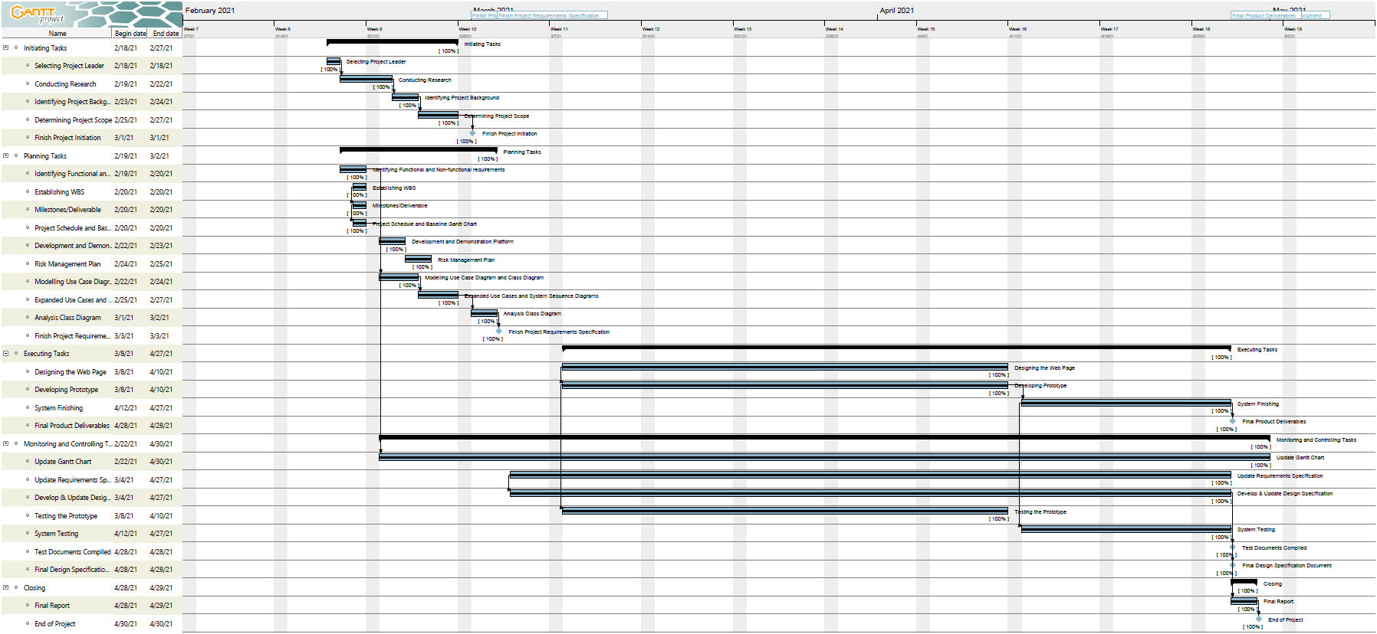

*Figure 69. Gantt Chart*

There are no issues with our schedule, everything went well according to plan. There were no over deadlines works or any schedule changes.

* 1. **Collaboration via GitHub**

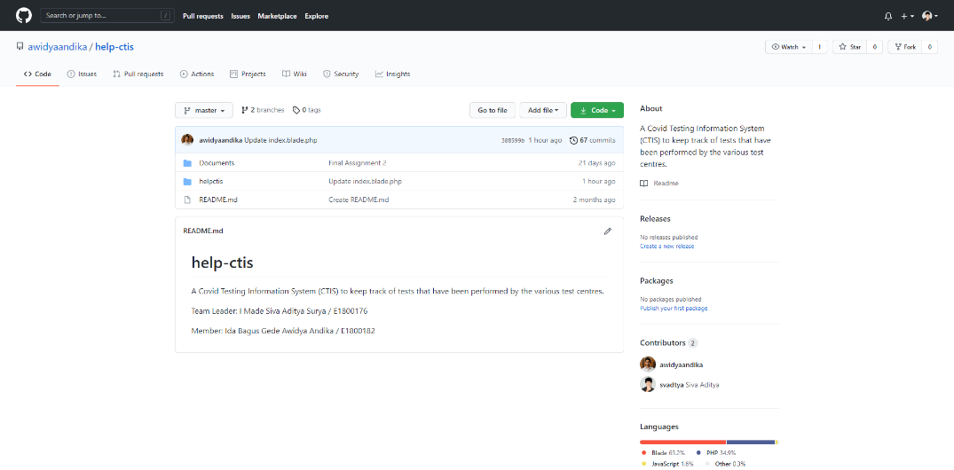

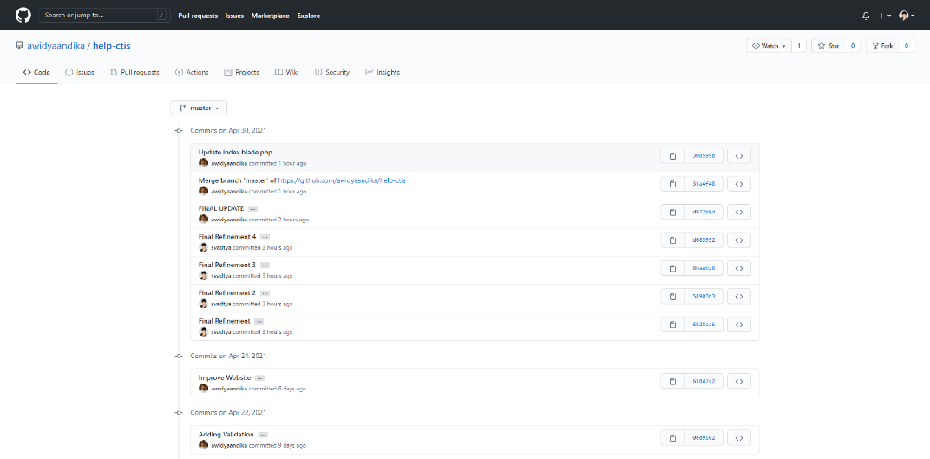

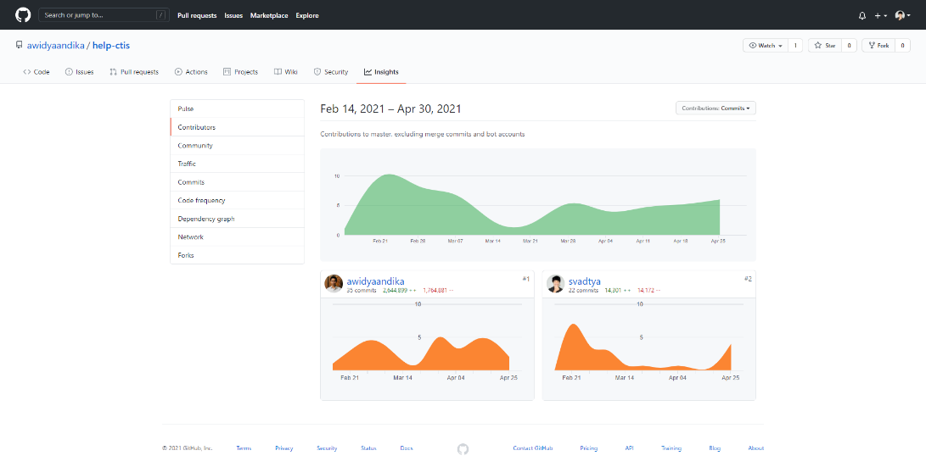

*Figure 70. GitHub Page*

We use GitHub as our software development collaboration tool which can be accessed through this link <https://github.com/awidyaandika/help-ctis>. Our GitHub was updated throughout the duration of the project which starts from February 2021 until end of April 2021. We have two branches, branch master which contains project files and branch assignment which contains assignment files such as word documents and diagrams.

* 1. **Conclusion/Review**

**Review by: Ida Bagus Gede Awidya Andika**

* **Did the group meet the objectives defined in Assignment 1?**

During the project from assignment 1 until assignment 3, project or website system built always updated until finally that fulfilled the predetermined project objectives. Both from website system that runs perfectly and the website can be accessed either via PC or smartphone devices.

* **What went wrong and what went right?**
* Went wrong in our project are there is still lack of understanding about making good and correct System Design such as System Sequence Diagram, Contracts and Database Design. Also happened during Architectural Design work such as Design Class Diagram, ERD, and Site Map. So these two things are done based on our knowledge that we have and references that we get from internet and materials that we have studied in previous courses.
* Went right in our project are during website system creation, everything was done based on System Design and Architectural Design that had been made, even some additional features on the website system that we built outside of System Design that had been made because of our great sense of enthusiasms and curiosity. Besides that, project system that we made done on time and ran perfectly.
* **What you would have done differently?**

Website system that we built done using the Laravel framework, where we have no experience and never use the framework.

The reason we use Laravel framework because it feels easy to use which is had good error handler feature so that if there is error it will immediately told where the error is. Beside that it is automatically connected to the database server, so that can create database directly from Laravel without making manual in PHPMyAdmin and it is easy making CRUD (Create, Read, Update, Delete) because automatically formed in the controller and just adjust as needed. Not because this is our first experience using Laravel, the website system we built is imperfect, instead with help Laravel the website that we built can done quickly and the results exceed our expectations.

**Review by: I Made Siva Aditya Surya**

* **Did the group meet the objectives defined in Assignment 1?**

I feel that our group has succeeded in fulfilling the project objectives that we stated in assignment 1. The project initiation has been carried out quite well, equipped with supporting documents. Design specifications have been made in accordance with functional and non-functional requirements, there are several adjustments in terms of database design that are designed to support the effectiveness of using the framework on the website. All use cases have been implemented properly, the final product of the website is able to support our project goals, namely: to produce a system that supports good clinical management of COVID-19 testing and is able to carry out direct-to-patient reporting of COVID-19 test results. The test plan has been well designed, and all testing has been carried out for every existing use case with satisfactory results. Therefore, we can conclude that we think we have implemented and ended this HELP CTIS Website project quite well.

* **What went wrong and what went right?**
* What went wrong - In terms of document creation there is still a lack of references in making design specification documents so that some of the resulting diagrams and contracts do not meet the standards and rules for making proper document design software. I also feel that the class diagram still doesn't represent the website system as a whole, only important entities are represented in the diagram.
* What went right - We have worked on the project according to the project scope that we have stated in our project plan. so that all use cases can be implemented fairly well and done on time. We have added several features outside of our project scope, but the work has been controlled so that it does not interfere with the schedule plan that we have set.
* **What you would have done differently?**

We are working on this project using a framework which we are very unfamiliar with. This is the biggest obstacle as well as the biggest challenge in working on this project. We spent a lot of time studying the framework before we could use it to implement our use case. In working on other projects, we want to develop the project using a framework that we have mastered so that we can use development time to implement additional features that are outside the scope of the project and are the result of impromptu brainstorming, but we believe we can significantly improve the quality of our system in terms of design and functionality.

We also want to improve the quality of our design specification documents so that they meet standards and are able to better represent our system to the public and other developers.

**Overall Review**

We have worked on this project well in accordance with the project objectives, project scope, and project schedule that we have set in the first assignment. The thing that we feel the most lacking is the quality of our design documents which is still low due to the lack of references so that they do not follow good design standards. In the future, we want to develop a project with a framework that we have fully mastered so that the results can be even better.

# **Bibliography**

Sommerville, I. (2016). *Software engineering 10th Edition*. Pearson Education.